

|  |
| --- |
| International School of Management Patna  (APPROVED BY AICTE, MINISTRY OF HRD GOVT. OF INDIA)        Project Report on  **“FlatFinder”**  (Pager code: 604)  In partial fulfilment of the requirements for the award of Degree  Of  BACHELOR IN COMPUTER APPLICATIONS  (SESSION: 2022-2025)        **Report Guide:- Submitted By:**  Mr. Shanu Sir Anish Kumar  Assistant Professor BCA(2022-2025)  IT , ISM PatnaReg. No. : 21303313061 |

|  |
| --- |
| International School of Management Patna  (APPROVED BY AICTE, MINISTRY OF HRD GOVT. OF INDIA)        Batch 2021 – 2024  Project Report on  “**FlatFinder**”        **Report Guide: Submitted By:**  Mr. Sanu Sir Anish Kumar  Assistant Professor BCA(2022-2025)  IT , ISM PatnaReg. No. : 21303313061        Internal Examiner External Examiner |

|  |
| --- |
| Declaration    I hereby declare that the Project Work titled **“Flat Finder Mobile Application”** has been carried out by me under the guidance of **Mr. Sanu Sir (Assistant Professor)** at **International School of Management, Patna**. This work is original and developed as part of my academic curriculum. I confirm that the project does not violate any plagiarism norms and is the result of my own development, design, and research efforts.  I also declare that this Project has not been submitted to any University/ Institute for the award of any Degree/Diploma.                    **Place:** Patna Anish Kumar  **Date:** Reg. No. – 21303313061 |

|  |
| --- |
| certificate    This is to certify that the Project Work titled **“Flat Finder Mobile Application”** has been accomplished by **Anish Kumar**, **Reg. No. – [Your Registration Number]**, **BCA**, under my guidance and supervision. This project is being submitted by him as the partial fulfilment of requirements for the award of **Bachelor of Computer Applications (BCA)** from **International School of Management, Patna**, an affiliated unit of **Aryabhata Knowledge University, Patna**.  This work has not been submitted by him anywhere else for the award of any degree or diploma. All sources of information and assistance have been duly acknowledged.                **Project Guide:**  Mr. Sanu Sir  Assistant Professor  IT, ISM Patna |

acknowleDgement

The most awaited moment of successful completion of endeavour is always a result of persons involved explicitly or implicitly there in. It is impossible without the help and guidance of the people around to carry on this project work. I take the opportunity to express my sincere gratitude to each and every person who gave me the guidance and help for preparing the report.

I take this opportunity to thanks to (Management), International School of Management for providing me an opportunity to work for this Project.

I am also desirous of placing on record profound indebtedness to Mr. R. Dayal and all the members of faculty of International School of Management, Patna, for the valuable advice, guidance and support that they offered.

Last but not the least; I would also like to thanks all the respondents for giving me their time and relevant information.

My strength and inspiration are the blessings of my parents and my friends. I owe all my success and achievements to them.

- Anish Kumar

|  |  |  |  |  |  |  |  |  |  |  |  |  |  |  |  |  |  |  |  |  |  |
| --- | --- | --- | --- | --- | --- | --- | --- | --- | --- | --- | --- | --- | --- | --- | --- | --- | --- | --- | --- | --- | --- |
| Table of Content   |  |  |  | | --- | --- | --- | | S No. | Contents | Page No. | | 1.  1.1  1.2  1.3  1.4 | Introduction  Project Introduction  Objective of the Project  Scope of the Project  Applicability of the Project | 9 - 10 | |  |  |  | | 2  2.1  2.2  2.3  2.4  2.5 | Requirements and Analysis  Requirements Specification  Tools, Platforms and language used  Software and Hardware Requirements  Use Case Diagram  Project Category | 11 - 16 | | 3 | Feasibility Study | 17 | | 4 | Software Engineering Paradigm | 18 | | 5  5.1  5.2  5.3 | System Design  Basic Module Database Design  Procedural Design  5.3.1 Process Flow  5.3.2 Data Flow Diagram  5.3.3 ER Diagram | 19 - 39 | |

|  |  |  |  |  |  |  |  |  |  |  |  |  |  |  |  |
| --- | --- | --- | --- | --- | --- | --- | --- | --- | --- | --- | --- | --- | --- | --- | --- |
| |  |  |  | | --- | --- | --- | | 6. | User Interface Design | 40 – 50 | | 7. | Security Issues | 51 | | 8.  8.1  8.2  8.3  8.4 | Implementation & Testing  Implementation  Coding Details  Testing Approach  Modification & Improvement | 52 - 97 | |  |  |  | | 9  9.1  9.2  9.3  9.4 | Conclusion  Conclusion  Limitation of The Project  Future Scope of the project  Bibliography / Reference | 98 - 100 | |

|  |
| --- |
| 1. Introduction      * 1. **Project Introduction: -**   **Flat Finder** is a mobile application that helps users find rental flats directly from property owners. It makes renting simple, transparent, and hassle-free. With Flat Finder, owners can list their properties and set rental details. Renters can browse these listings, check photos, and contact owners directly. This removes the need for brokers and ensures better deals for both parties. Flat Finder aims to improve the rental process by connecting owners and renters in a single platform. It’s changing the way people search for flats, making it easier for everyone involved in the renting process.   * 1. **Objective of Project: -**   The objective of the **Flat Finder** project is to develop a mobile application that directly connects property owners with tenants to streamline the rental process. This platform aims to improve efficiency by simplifying flat searching, increasing transparency in rental pricing and availability, ensuring verified listings, and empowering property owners by expanding their reach. With a user-friendly interface, essential property management features, and scalability for wider adoption, Flat Finder seeks to offer a smooth and reliable experience for both owners and tenants.  The main objective of Flat Finder is to eliminate brokers, reduce rental fraud, and provide fair, direct deals to both parties.      P a g e |

|  |  |
| --- | --- |
| **1.3 Scope of Project: -**   |  | | --- | | **Flat Finder app** aims to build a platform that links renters and property owners directly. This app will help users find and rent flats without any middlemen, reducing hassle and ensuring fair deals for everyone. The app will be easy to use from anywhere and will provide useful information to help renters and owners make better decisions. |     **1.4 Applicability of Project: -**  The applicability of the Flat Finder app extends across several important sectors and contexts, delivering meaningful benefits to each. In the real estate sector, Flat Finder empowers renters by providing a direct platform to connect with property owners, eliminating intermediaries and helping renters find flats at fair prices. This direct connection improves transparency and affordability in the rental market.  For property owners and landlords, the app offers an efficient way to list and manage rental properties, reaching potential tenants more effectively. This streamlines the leasing process and reduces vacancies, enhancing their rental income stability.  Flat Finder also optimizes the rental housing market by reducing time and costs related to traditional search and listing methods. By providing accurate, real-time property information and location-based search, the app improves convenience and satisfaction for both renters and owners.  Additionally, Flat Finder promotes market transparency by offering clear details on property availability, rental rates, and amenities, enabling better decision-making for all users involved.        P a g e 10 | 100 |

|  |
| --- |
| 1. Requirements and Analysis:      * 1. **Requirements Specification:**   Flat Finder will require features for user registration, property listing, search and filtering, booking or rental management, and secure payment processing.       * 1. **Tools, Platforms, and Languages Used:** * Application : Mobile Application * Client-Side/ Front-End : React Native(Expo) * Server -Side/Back-End : Python(Flask) * Database : PostgreSQL DataBase |

|  |  |  |
| --- | --- | --- |
| **2.3 Software and Hardware Requirements**: -    ➢ **Minimum Hardware Requirements: -**    (For Mobile user): | | |
| ( | Processor | Intel i3 |
| Ram | 1 GB |
| Hard Disk Drive | 500 GB |
| Cache Memory | 1024 KB |
| Peripheral Devices | Monitor, Keyboard, Mouse |
| For Mobile Users) :   |  |  | | --- | --- | | Ram | 2 GB | | Internal Memory | 16 GB | | Screen Resolution | 1080*1920 |   P a g e 12 | 100 | |

|  |  |  |  |  |  |  |  |  |  |  |  |  |
| --- | --- | --- | --- | --- | --- | --- | --- | --- | --- | --- | --- | --- |
|  **Minimum Software Requirements: -**    (For PC/Laptop Users) :     |  |  | | --- | --- | | Operating System | Windows , Linux, MacOS web | | Web Browser | Chrome, Safari, Brave, Edge etc. | | Internet | Wired or Wireless |       (For Mobile Users) :     |  |  | | --- | --- | | Operating System | Android, iOS web browser | | Web Browser | Chrome, Mozilla, safari, Tor | | Internet | Wired or Wireless | |

CONTACT OWNER

SAVE TO FAVORITIES

SEARCHH

LOG OUT

VIEW PROFILE

EDIT PROFILE

FORGET PASSWORD

LOGIN

RAGISTER

BEFORE LOGIN

AFTER LOGIN

2.4

Use case Diagram

**RENTER**

**RENTER**

**OWNER**

Signup/Login

Update Property

Update date

**owner**

Update Rent

Update Booking status

Update Profile

Add property

Add Rent

Add Photo of property

View user/owner

**ADM**

**IN**

**2.5**

**Project Category:**

The FlatFinder project falls under the category of Real Estate and Rental Property Management. It utilizes technology to build an online platform that connects property owners with prospective tenants, streamlining the rental process and improving housing accessibility. This project combines aspects of property listing services, digital marketplaces, and location-based search features to enhance the efficiency and transparency of the rental housing ecosystem. It focuses on simplifying property discovery for renters while enabling owners to manage and promote their listings with ease.

View Property



Delete user/owner

Delete Proprty

**Admin**

**Login**

|  |
| --- |
| 3. Feasibility Study:-    The feasibility study is a technique used to assess whether the proposed system is practical and implementable. I have conducted a feasibility study to determine if the **FlatFinder system** can be developed and used effectively. There are several types of feasibility studies conducted for this project:-     1. **Technical Feasibility: -**   The technical feasibility study evaluates whether the required technologies for developing the FlatFinder platform—such as web and mobile frameworks, databases, and mapping services—are available and compatible. It also checks if the system can be efficiently developed using current technical resources.   1. **Economical Feasibility: -**   The economic feasibility study examines the cost-effectiveness of developing the FlatFinder system. It analyzes development costs, server expenses, potential revenues from advertisements or subscriptions, and whether the long-term financial benefits justify the investment.     1. **Operational Feasibility: -**   This study evaluates if the FlatFinder app can function smoothly within real-world conditions. It checks whether users (renters and owners) can easily use the app’s features such as searching, listing, and contacting, and whether the organization can support its operations and updates.     1. **Behavioural Feasibility: -**   Behavioural feasibility assesses how end users will accept and adapt to the FlatFinder app. It considers factors like users’ comfort with digital platforms, willingness to use online property search tools, and how well the system fits into their existing behavior and expectations. |

4

. software

e

ng

i

neer

i

ng para

Di

g

m

:



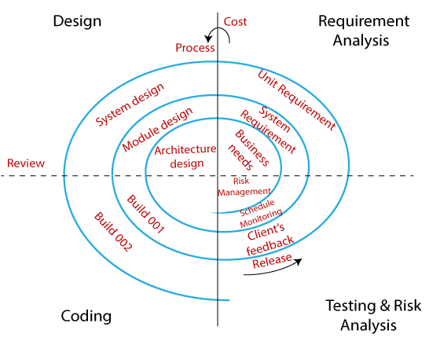

|  |
| --- |
| 1. system Design       **5.1 BASIC MODULES:**    The **FlatFinder** system is designed as an online platform that connects property owners with tenants looking for rental accommodations. It consists of three main modules: **Admin, Owners, and Renters**.  ➢ **Admin Module:**    **Functionality:** The Admin module allows administrators to manage the overall platform, including overseeing users and property listings.   * **Features:**   **o View Users**: Admins can view registered owners and renters.  **o Manage Listings**: Admins can monitor or remove inappropriate property listings.  **o Approve Properties**: Admins can review and approve new property submissions.  **o Delete Users**: Admins can remove users violating platform policies. |

|  |
| --- |
| ➢  **Owners Module**    **Functionality:** The Owners module enables property owners to add, update, and delete their property listings.   * **Features:**    + **Add Property:** Owners can list a property with details like rent, address, and type..   ▪ Set Rent  ▪ Add Address     * + **Update Property:** Owners can update property information like price, amenities, and availability.     ▪ Update Rent  ▪ Update Amenities     * + **Delete Property:** Owners can remove their listings from the platform. |

|  |
| --- |
| ➢ **Renters Module:**    **Functionality:** The Renters module allows users looking for flats to search, view, and book property visits.   * **Features:**    + **Search:** Renters can search for properties using filters like budget and type.   + **Browse:** Renters can explore available flats by location and details.   + **Save to Favorites:** Renters can mark preferred flats for easy access.   + **Profile:** Renters can manage their profile, including login/logout, registration.   ▪ Search ▪ Browse ▪ Save to Favorites ▪ View Details ▪ Book Visit / Inquiry  ▪ **Profile**  ▪ Login/logout  ▪ Register  ▪ Edit Profile  This system design outlines the key functionalities and features of the FlatFinder platform, focusing on connecting property owners with potential tenants while offering a seamless and user-friendly experience for renters. |

|  |
| --- |
| **5.2 DataBase Design: -**    □ **DataBase schema:**  Since I am using PostgreSQL Database for my project, the equivalent of "Tables" in SQL Database is referred to as "Tables" in PostgreSQL Database. So, this project consists of the following Tables:     * **User Table:**    + This table stores information about users registered on the platform.   + It has seven columns:     - user_id: a unique identifier for each category (primary key).     - name: the full name of the user.     - Mobile : the contact number of the user.     - Email: the email address of the user.     - Password: the password for login authentication.     - Gender: gender of the user (M, F, T).     - role: role of the user (Owner or Renter or Admin).        * **Property Table:**    + This table stores information about properties listed on the platform.   + It has eleven columns:   • property_id: a unique identifier for each property (primary key).  • user_id: a foreign key referencing the user_id in the User Table, indicating the owner of the property.  • property_type: the type of property (Flat, Room).  • rent: the monthly rental amount.  • address: the address of the property.  • Pin_Code: the postal code of the property location.  • dimensions: size or dimensions of the property.  • accommodation: specifies accommodation type (OnlyGirls, OnlyBoys, OnlyFamily, FamilyAndGirls, Both).  • is_occupancy: indicates if the property is currently occupied.  • is_parking: indicates if parking is available.  • is_kitchen: indicates if the property has a kitchen facility. |

|  |
| --- |
| * **Photo Table:**    + This table stores photos related to users and properties.   + It has six columns:   • photo_id: a unique identifier for each photo (primary key).  • photo_type: the type of photo (Profile_pic, Property_pic).  • photo_id_link: the link or path of the photo file.  • user_id: a foreign key referencing the user_id in the User Table (nullable).  • property_id: a foreign key referencing the property_id in the Property Table (nullable).  • CHECK constraint: ensures that either user_id or property_id is not null. |

|  |
| --- |
| **5.3 Procedural Design: -**    **5.3.1 Process Logic: -**  The login process for the FlatFinder system provides an overview of the essential terms and conditions users need to follow to access the system's features like registering, listing, or browsing flats and rooms. It also explains how information flows within the system.  When users register, they agree to the platform’s terms of service and privacy policy. Many features of the FlatFinder system are accessible only to registered users. Once registered, users can receive regular updates via email about new property listings, available rentals, and important announcements. |

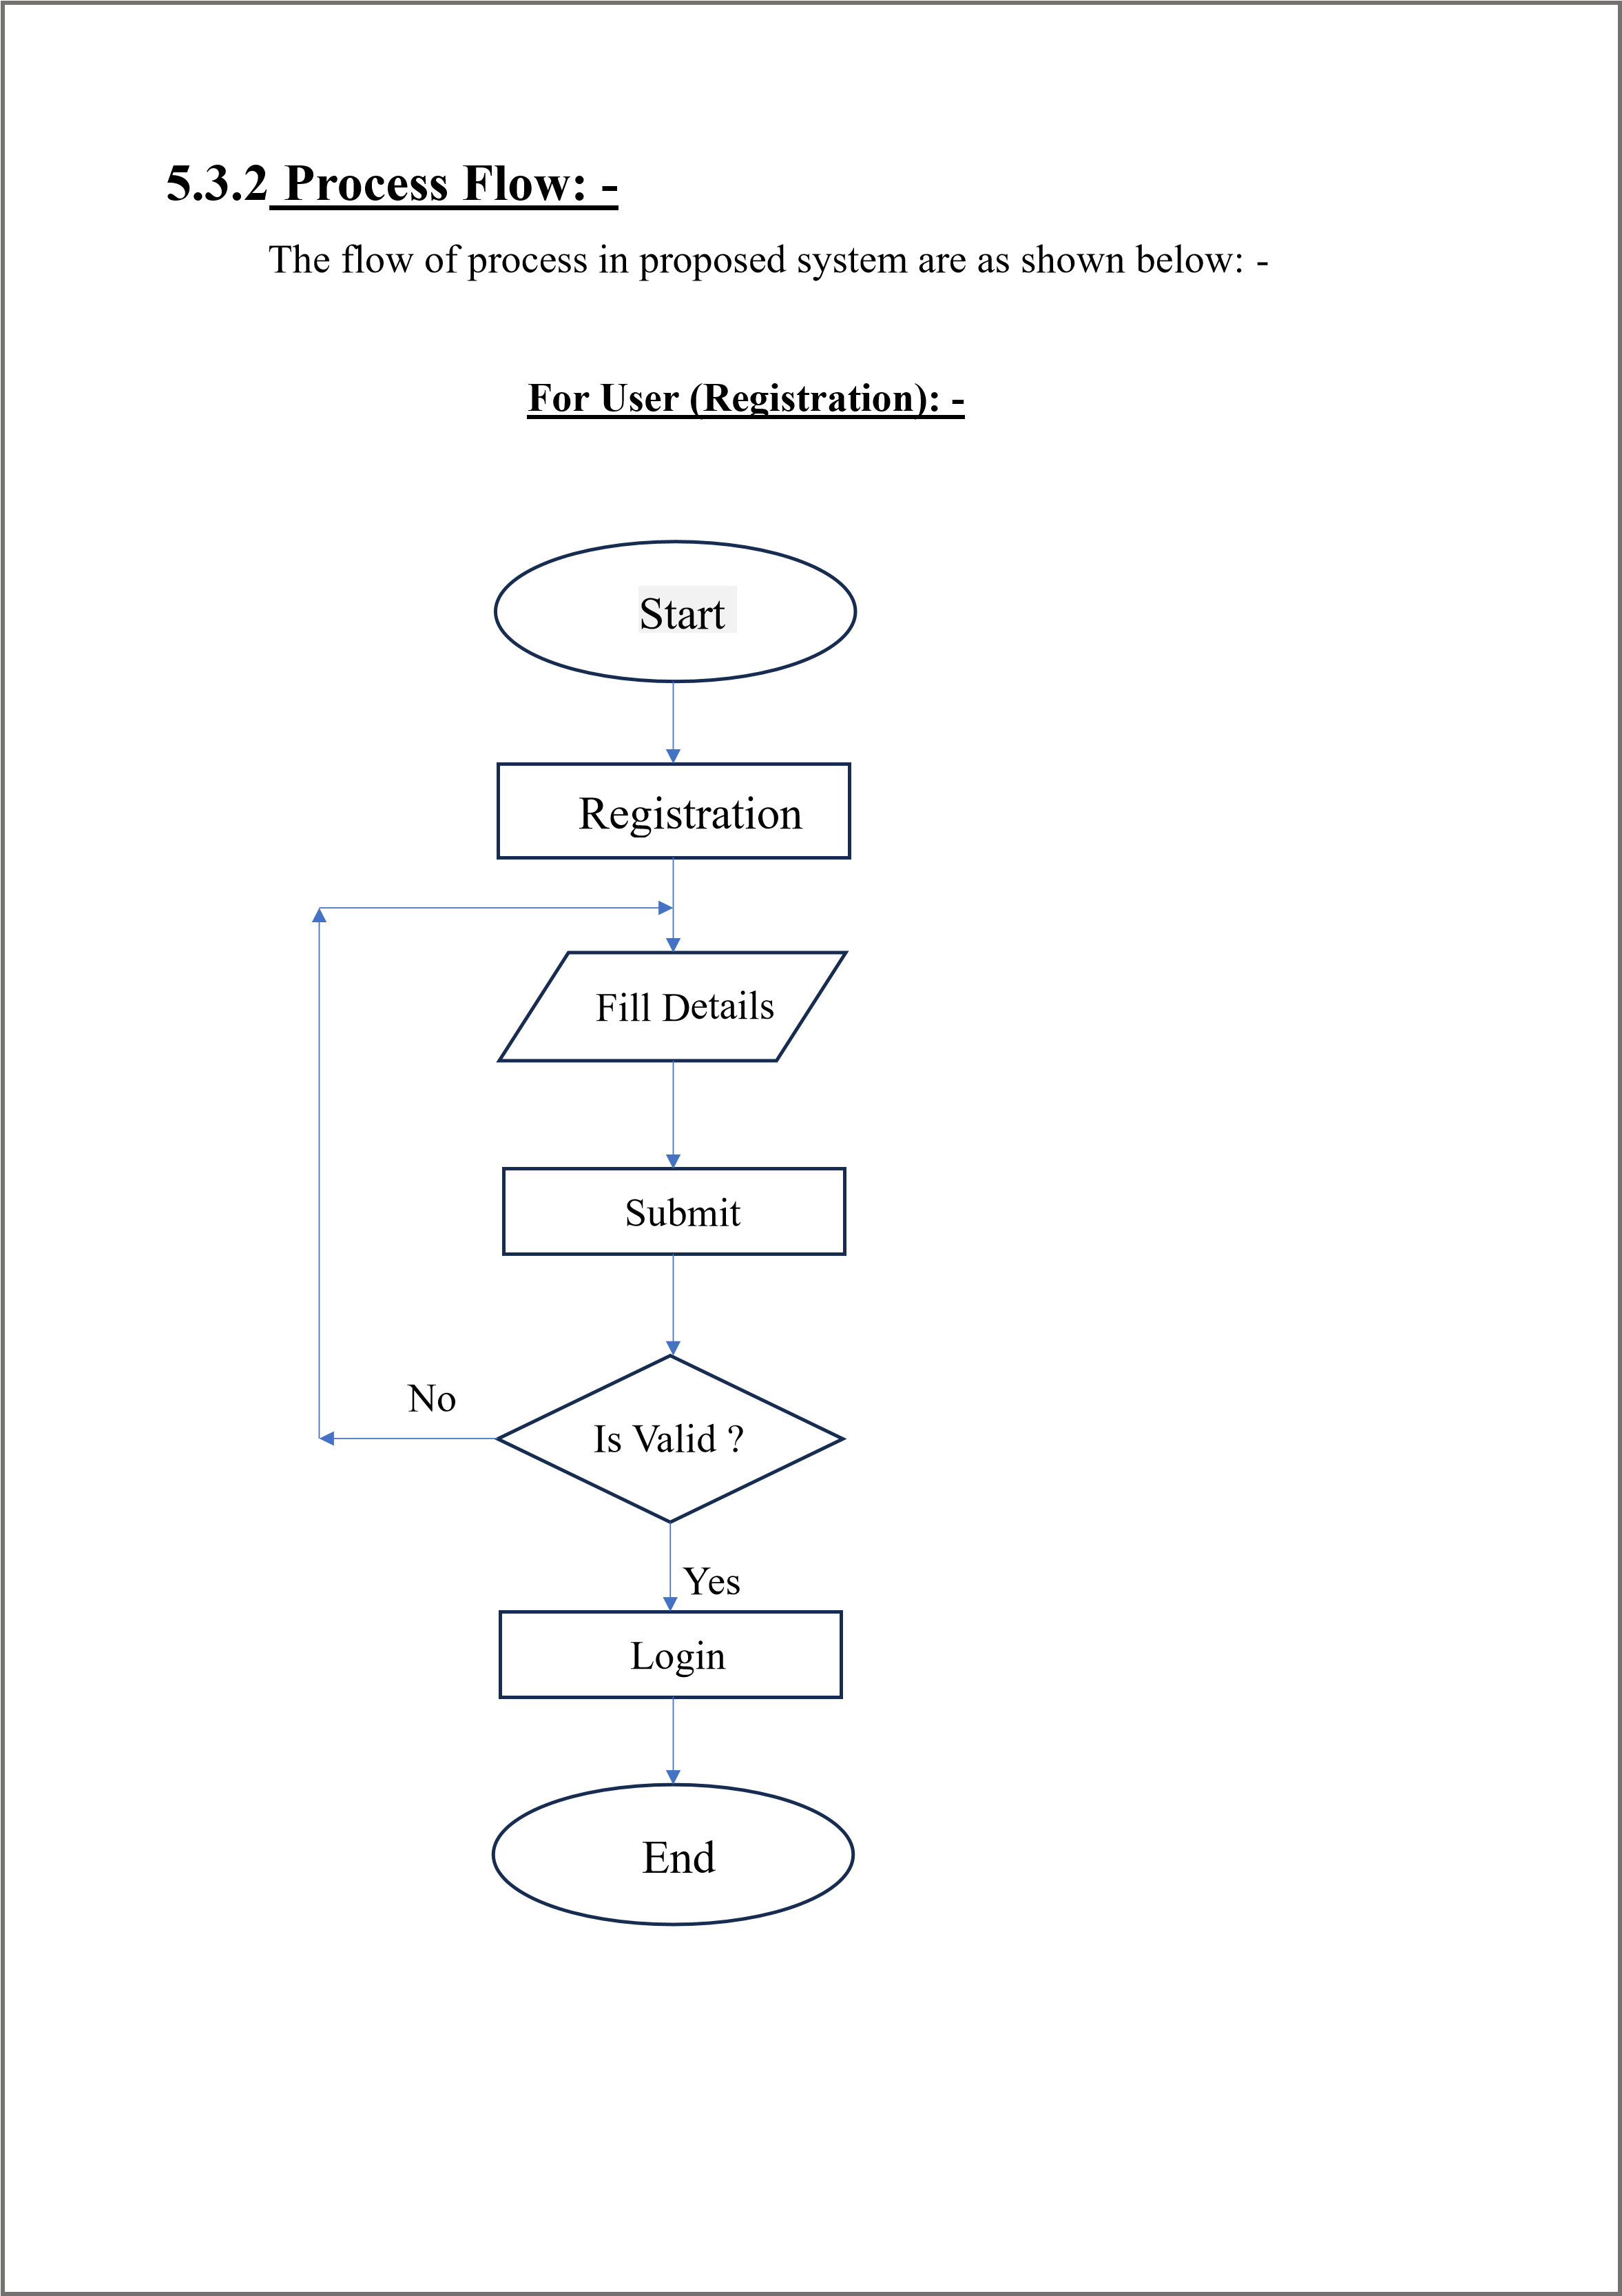

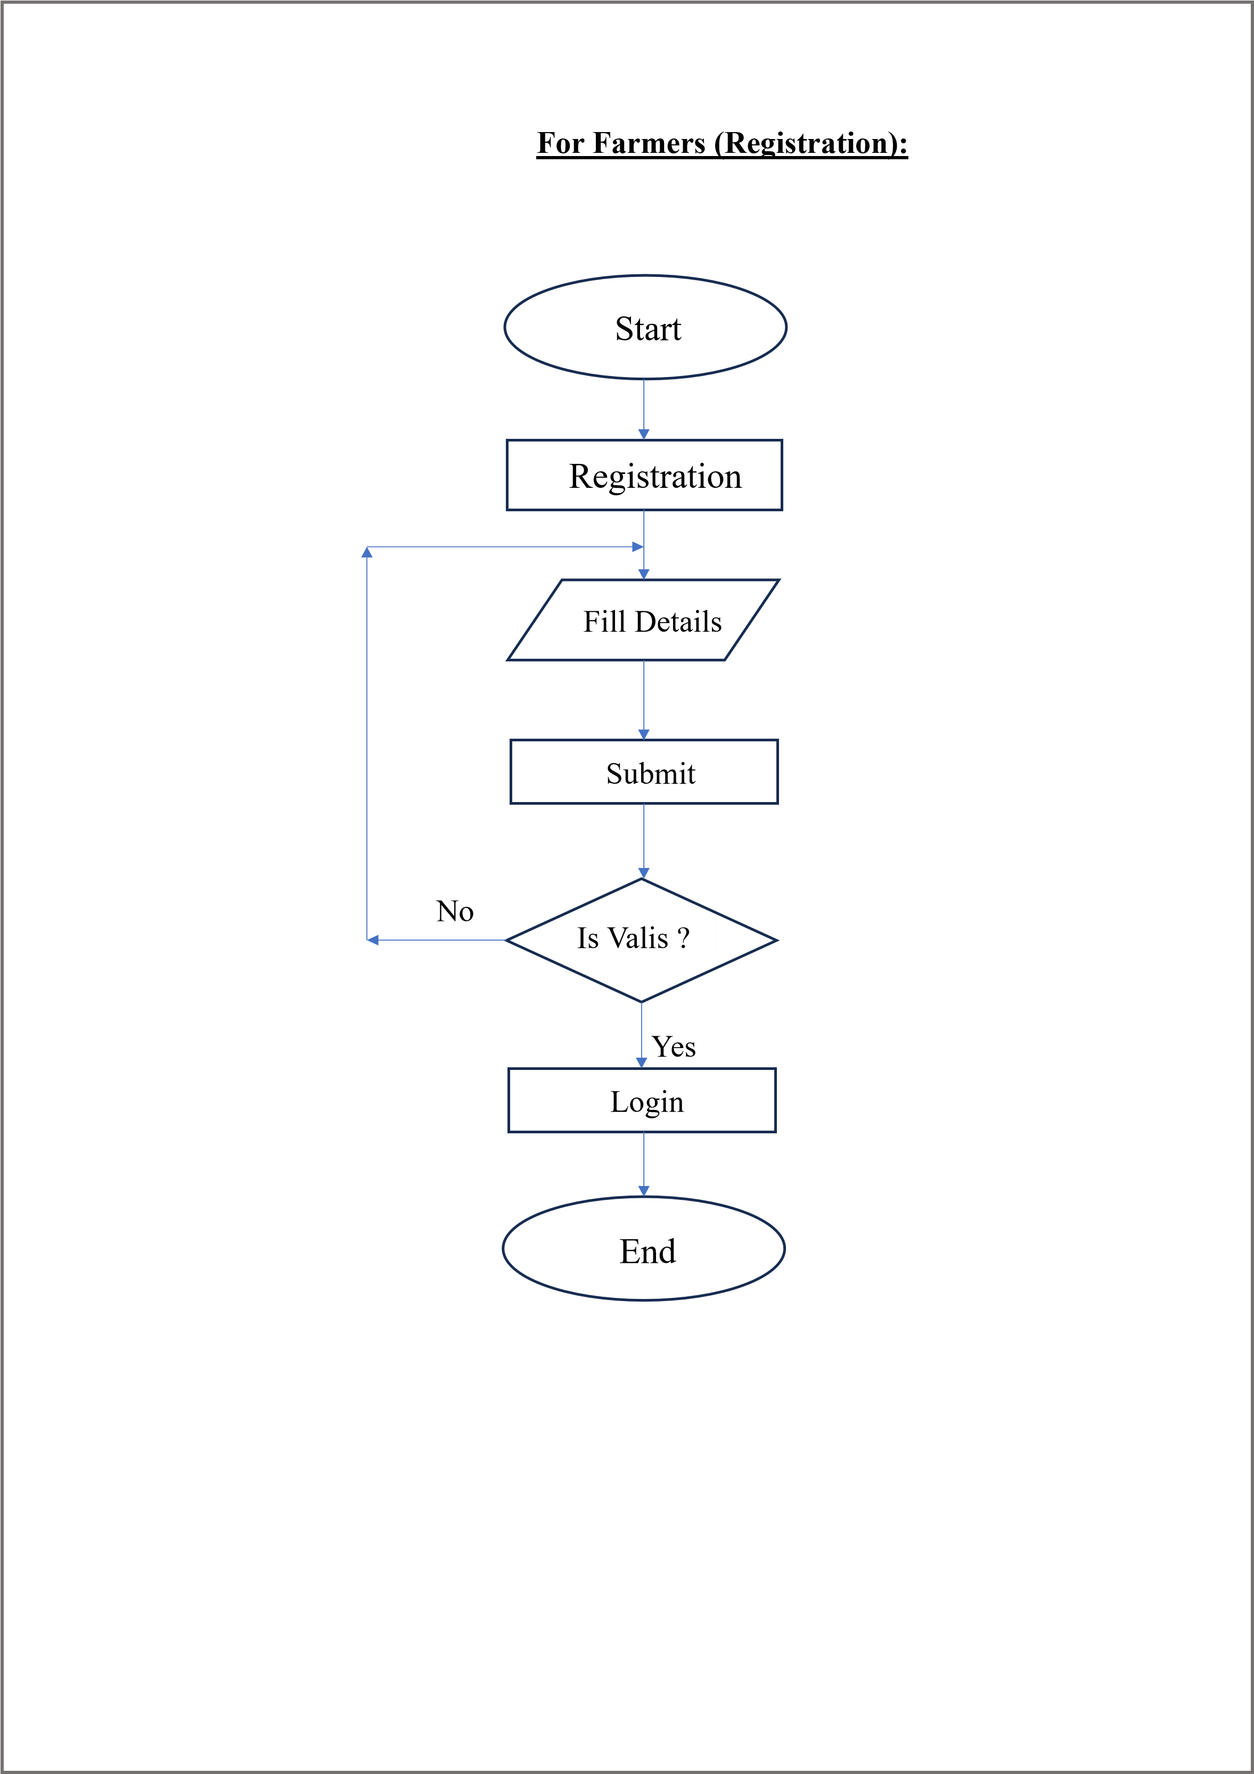

**For Owners (Registration):**

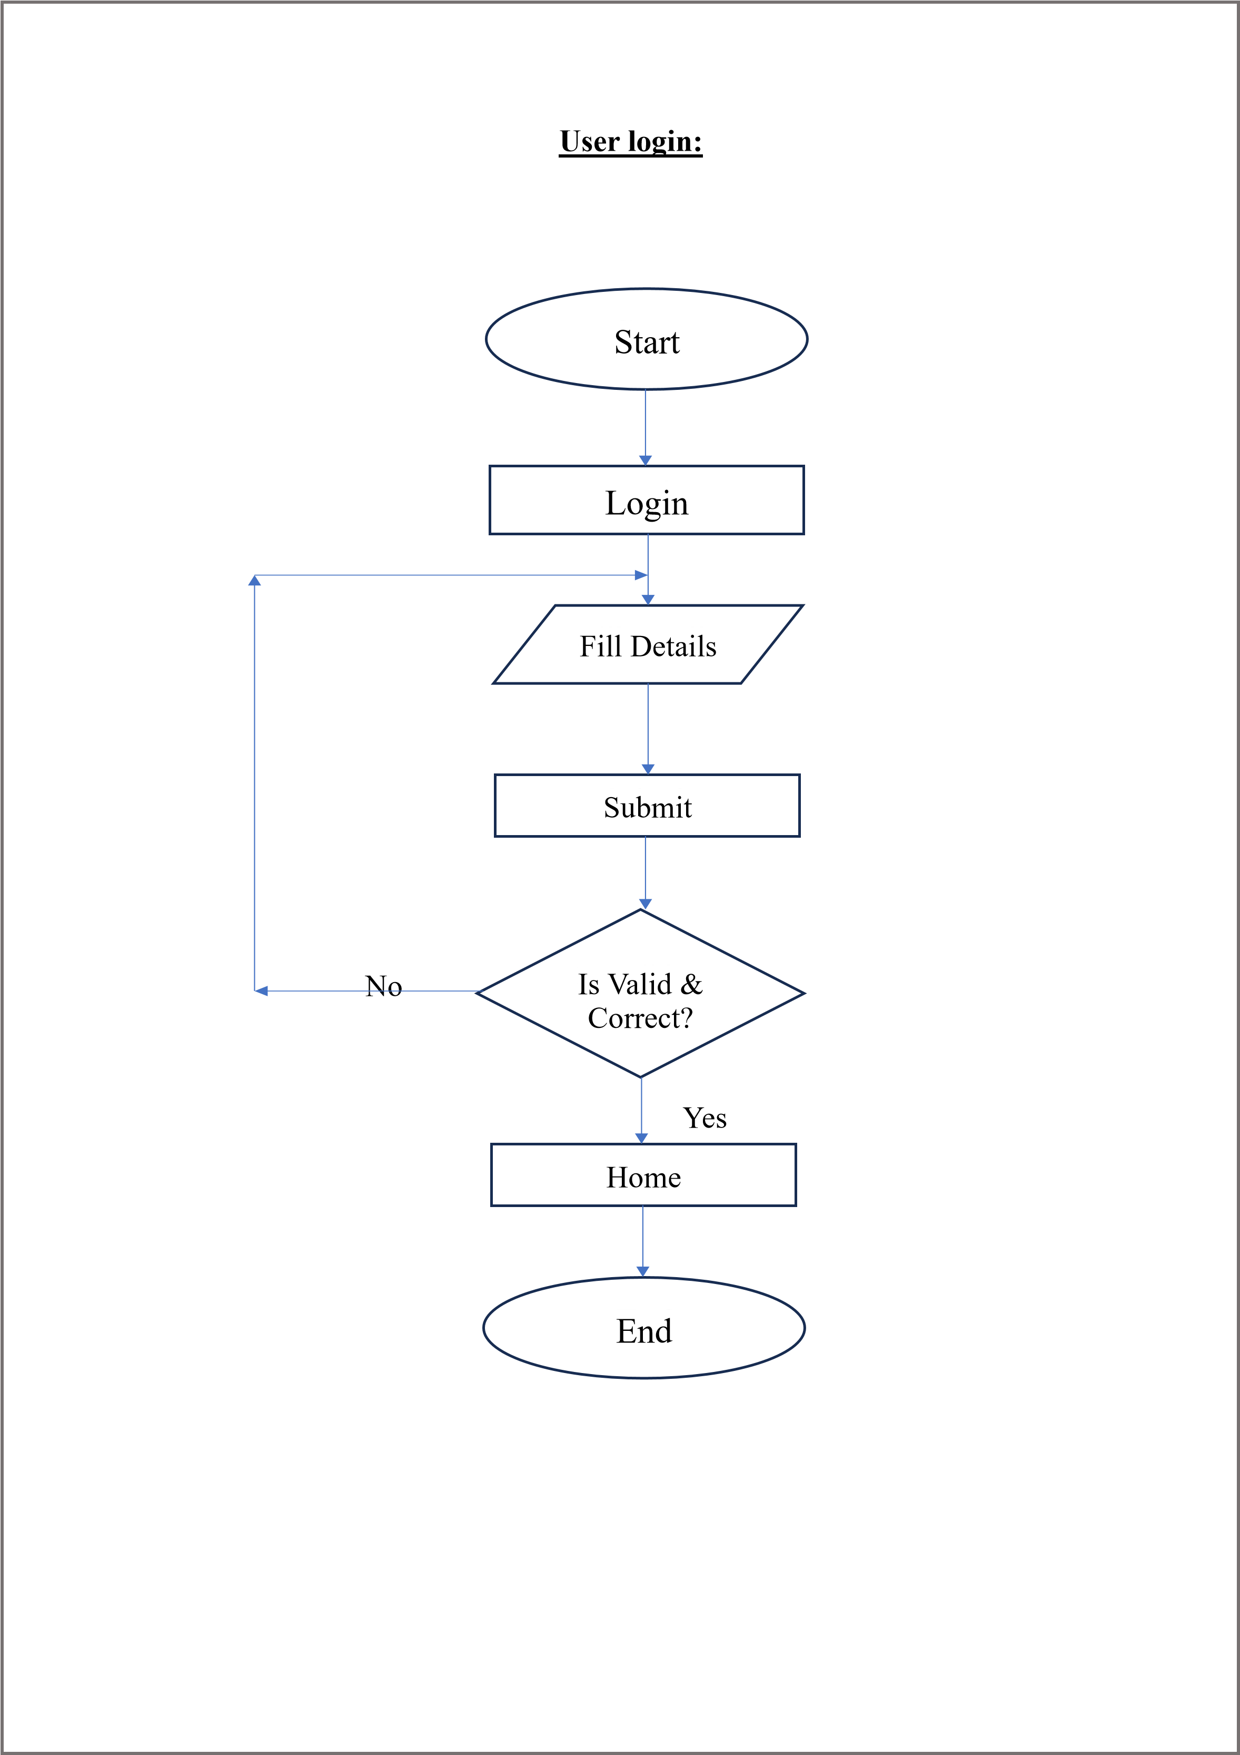

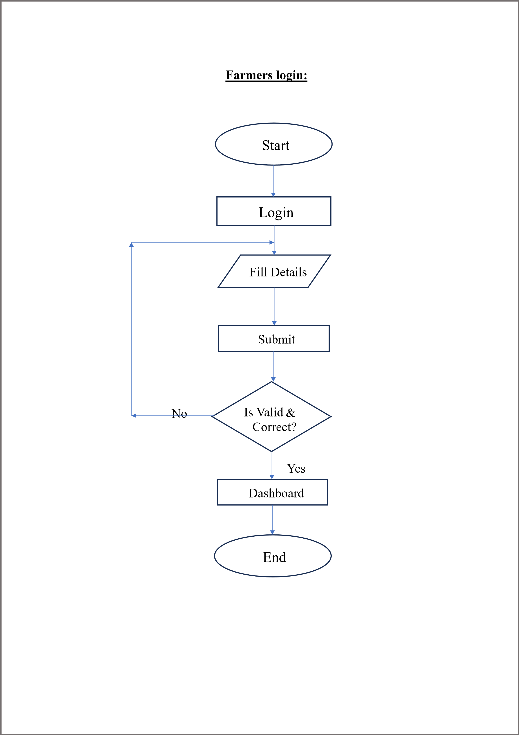

**Owners Login**

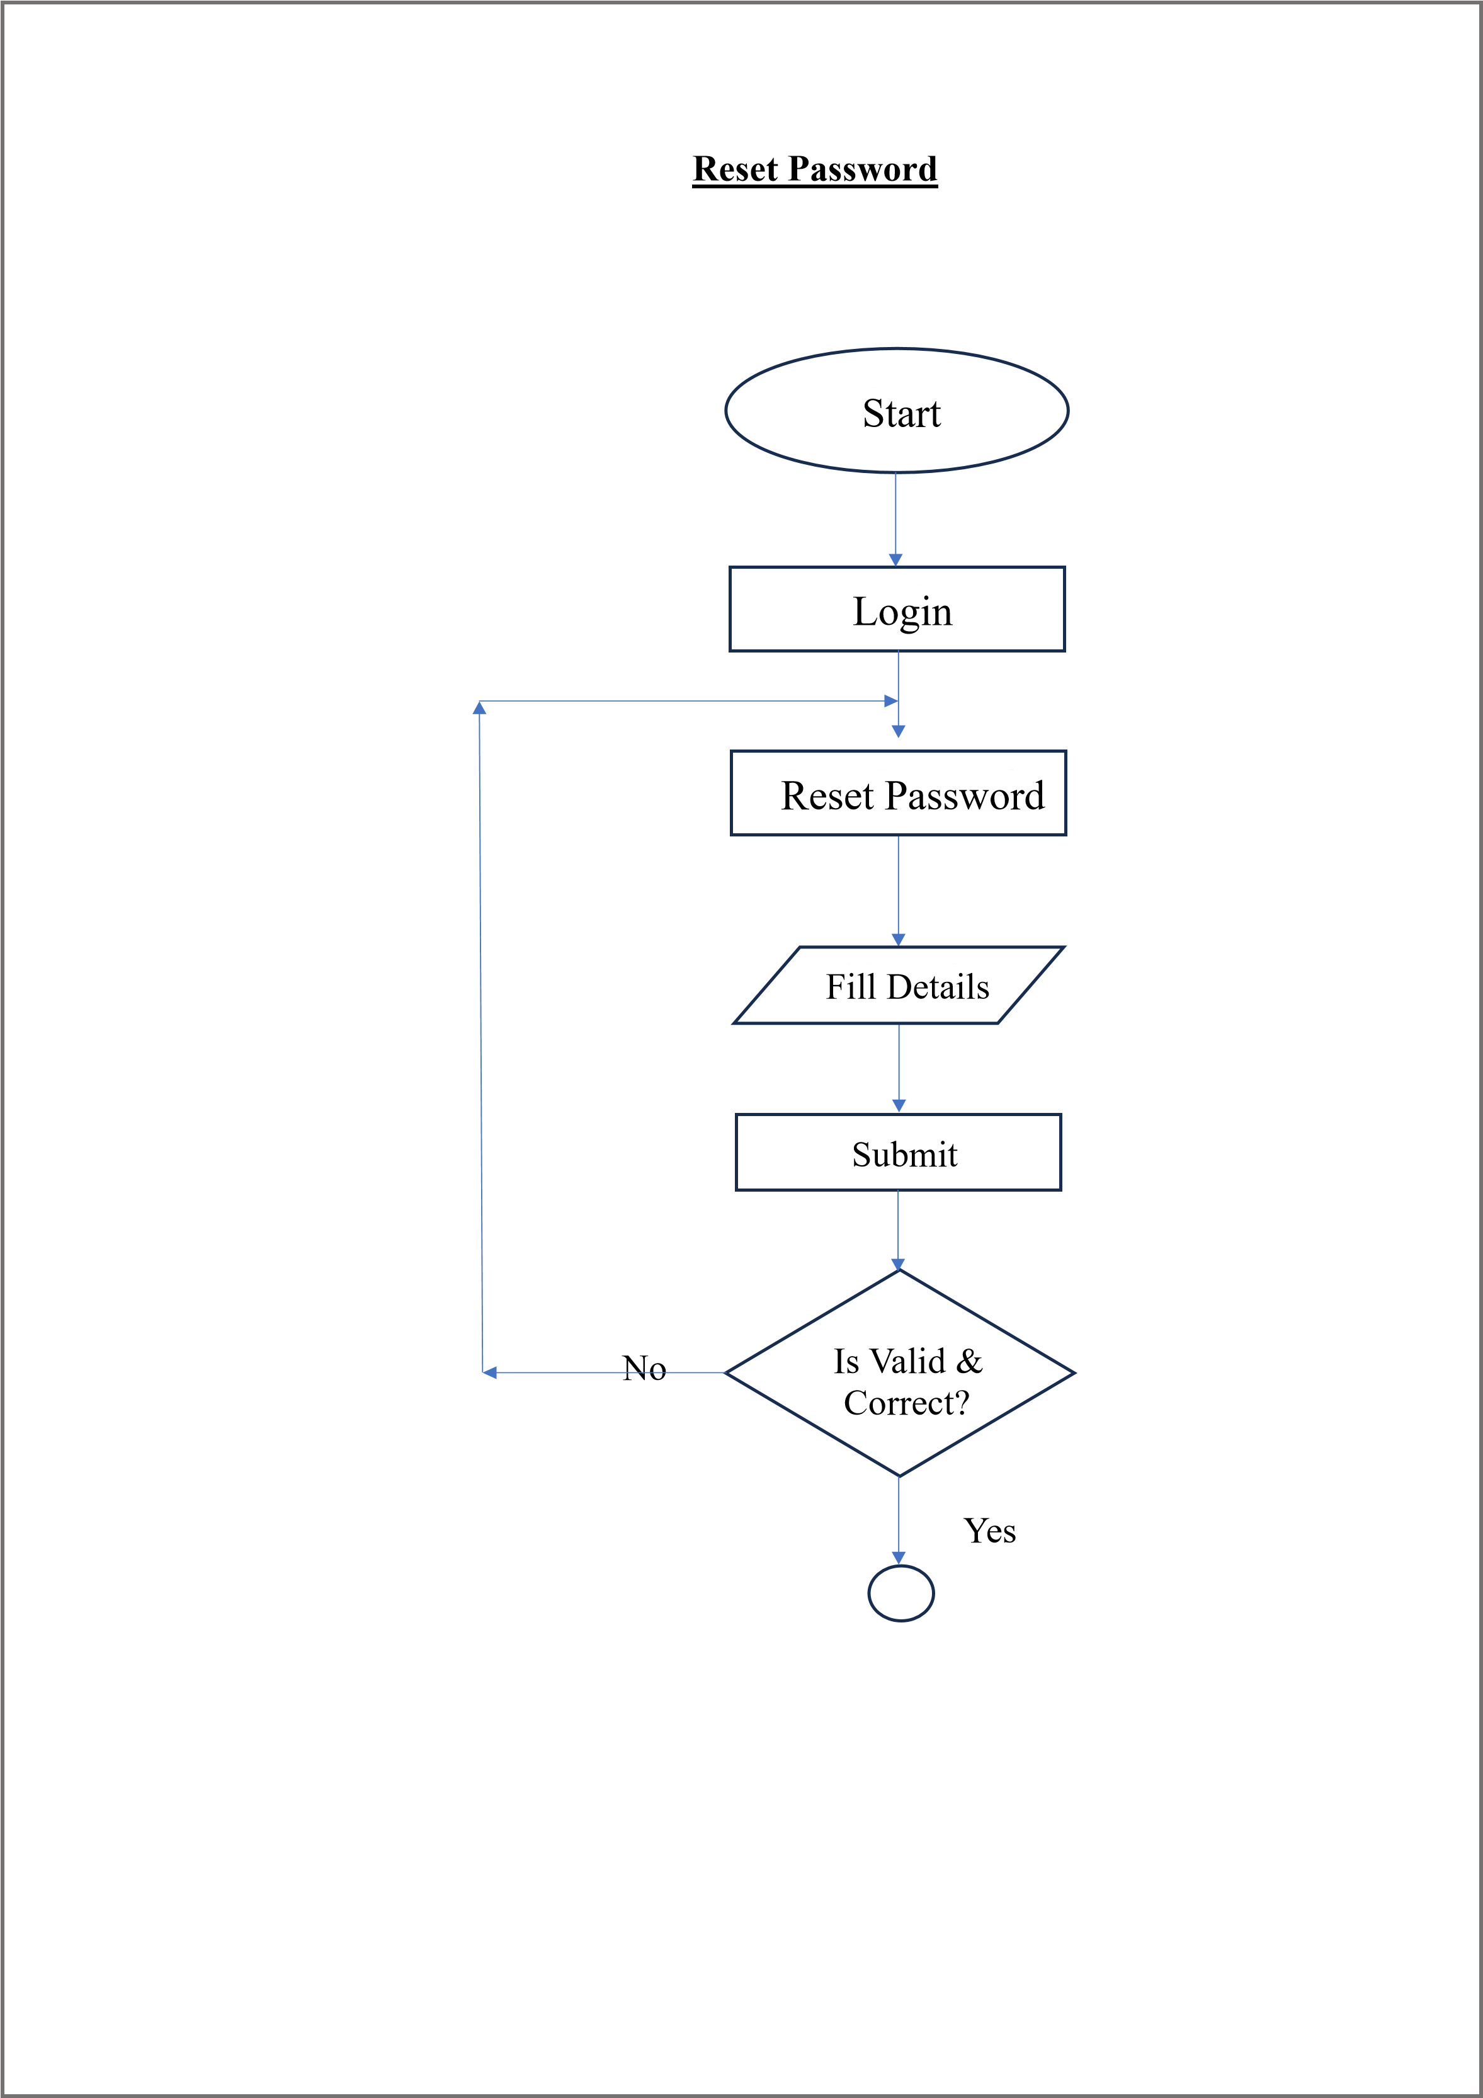

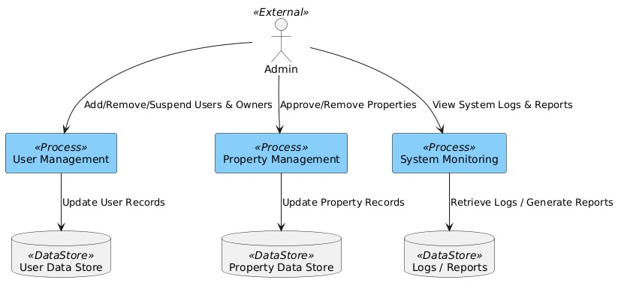 A2

**5**

**.3.3**

**Data Flow Diagram:**

**-**

□

**0**

**-**

**Level DFD**

**:**

❖

**ADMIN SIDE**

**DFD:**

**I.**

**Level**

**-**

**1**

**:**

User

Owner

Admin

Flatfinder

Flask Backend

Database

login

Registration

login

login

Registration

Connect

Retrieve

**2. Level-2:**

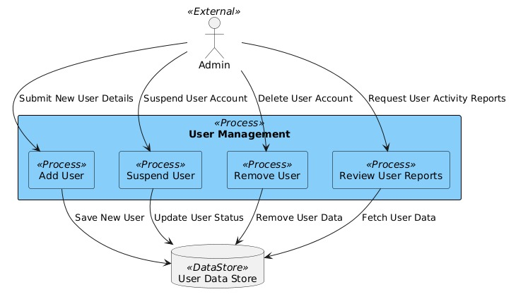

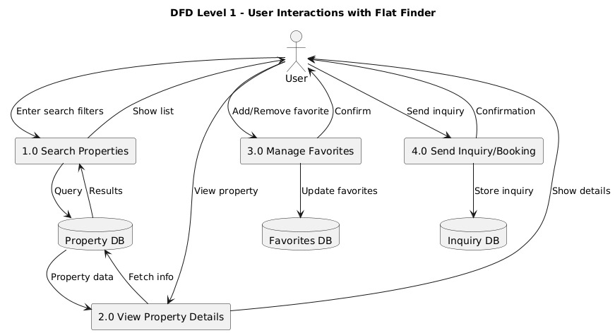

**User side DFD:**

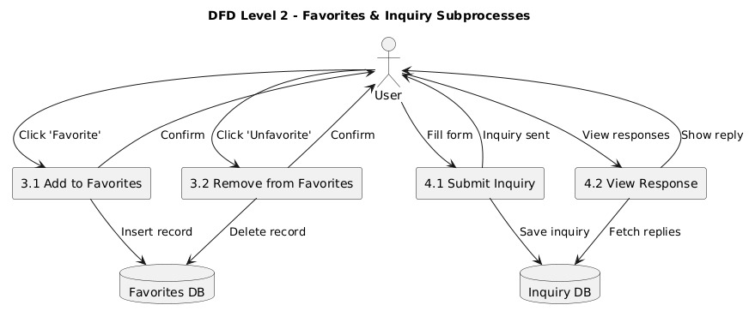

**.**

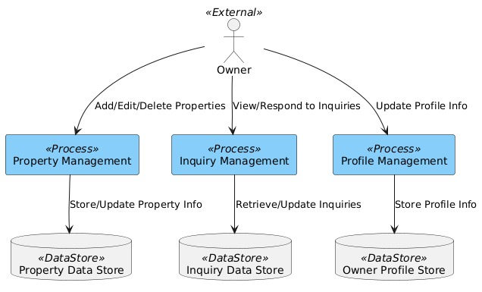

**Level 1:**

**Owner side DFD:**

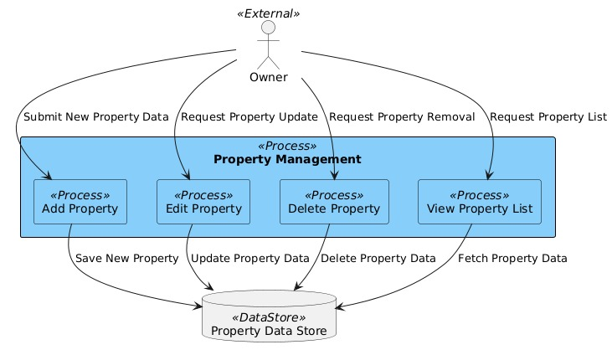 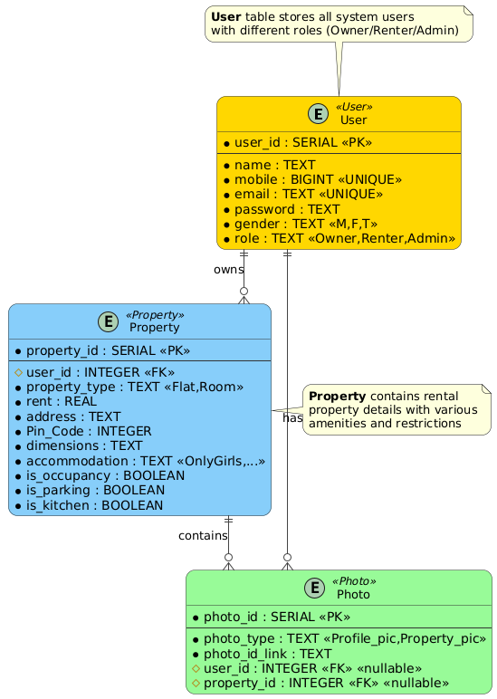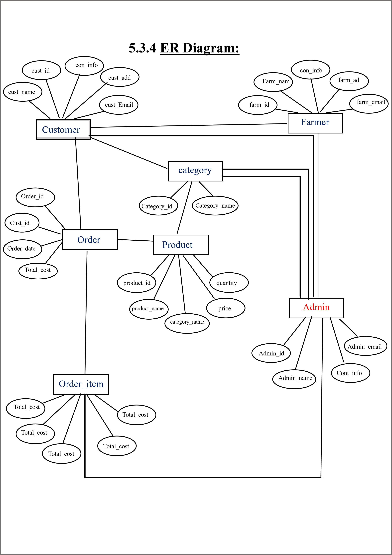

**Level 2:**

6.

User interface Design

:

▪

**HOME PAGE:**

o

**FEATURES:**

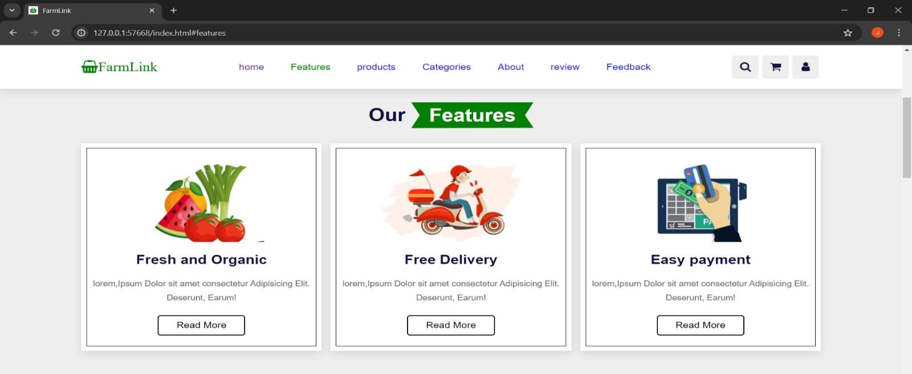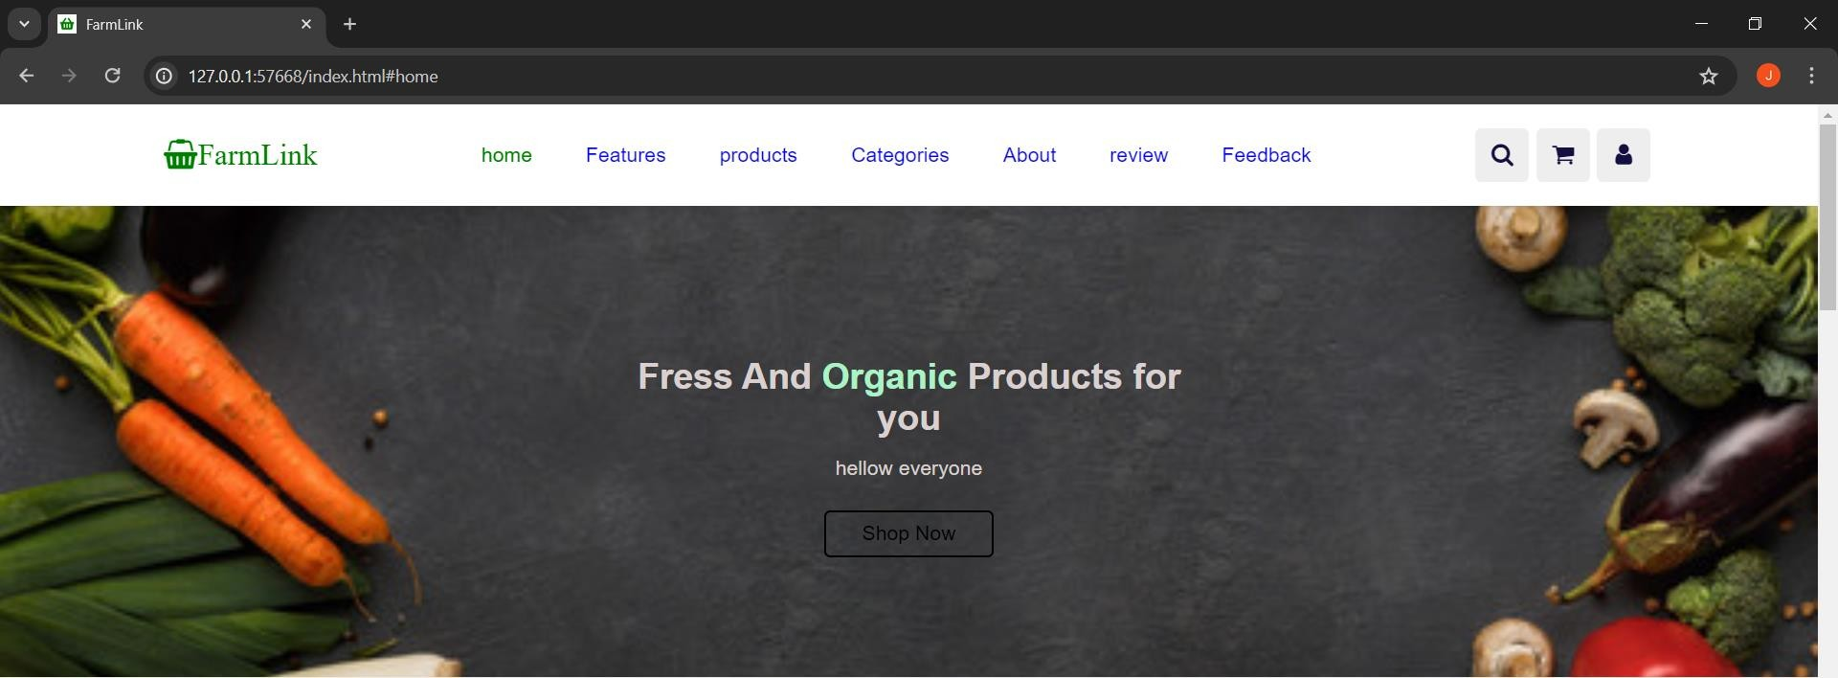

o

**PRODUCTS:**

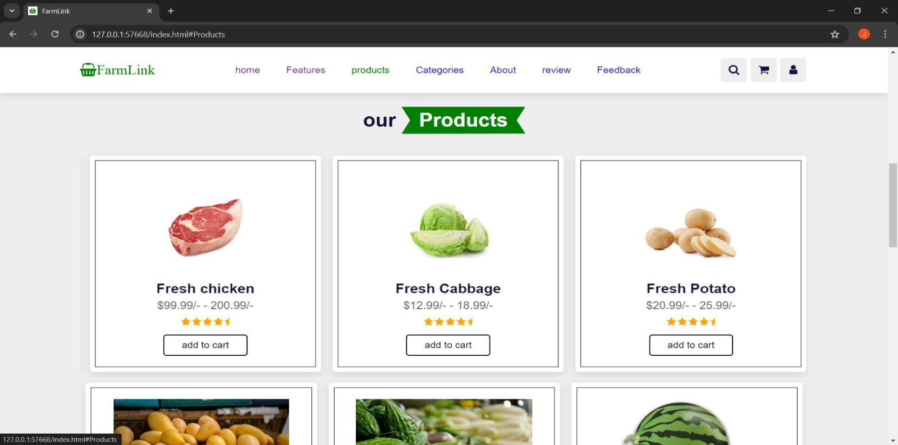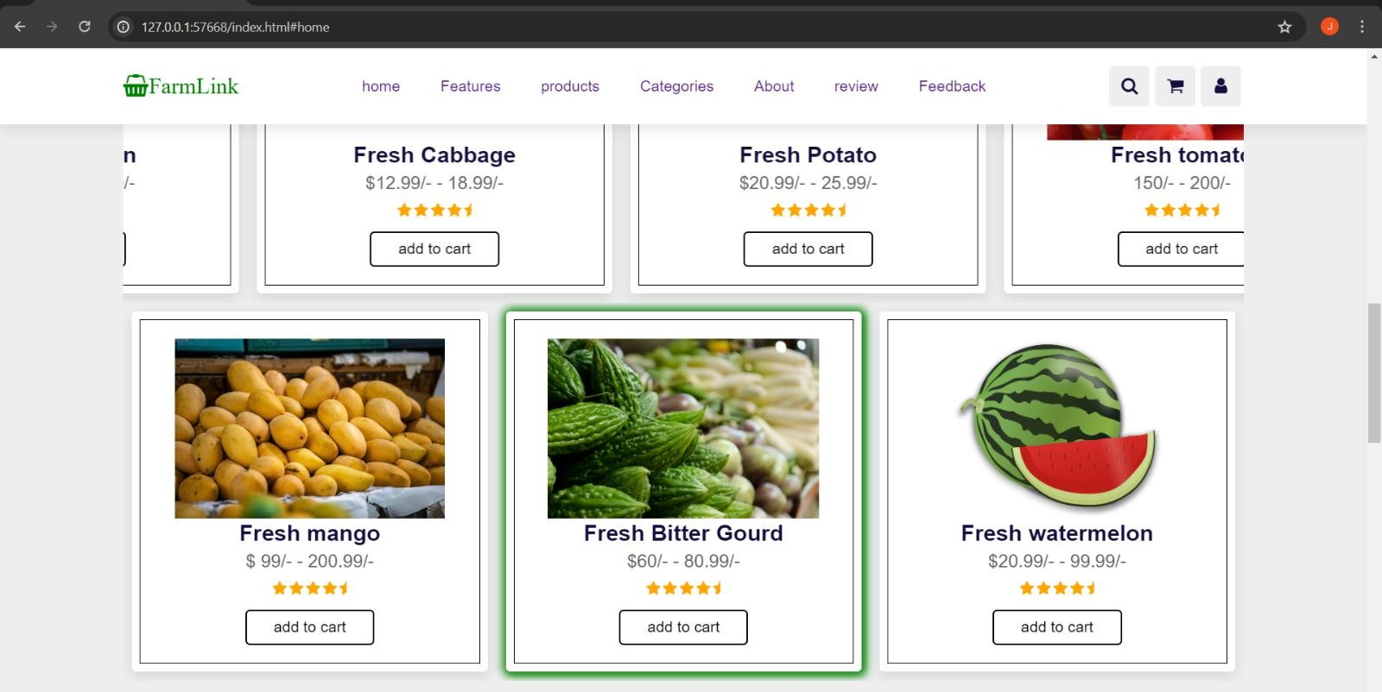

▪

**C**

**ATEGORIES**

**SECTION:**

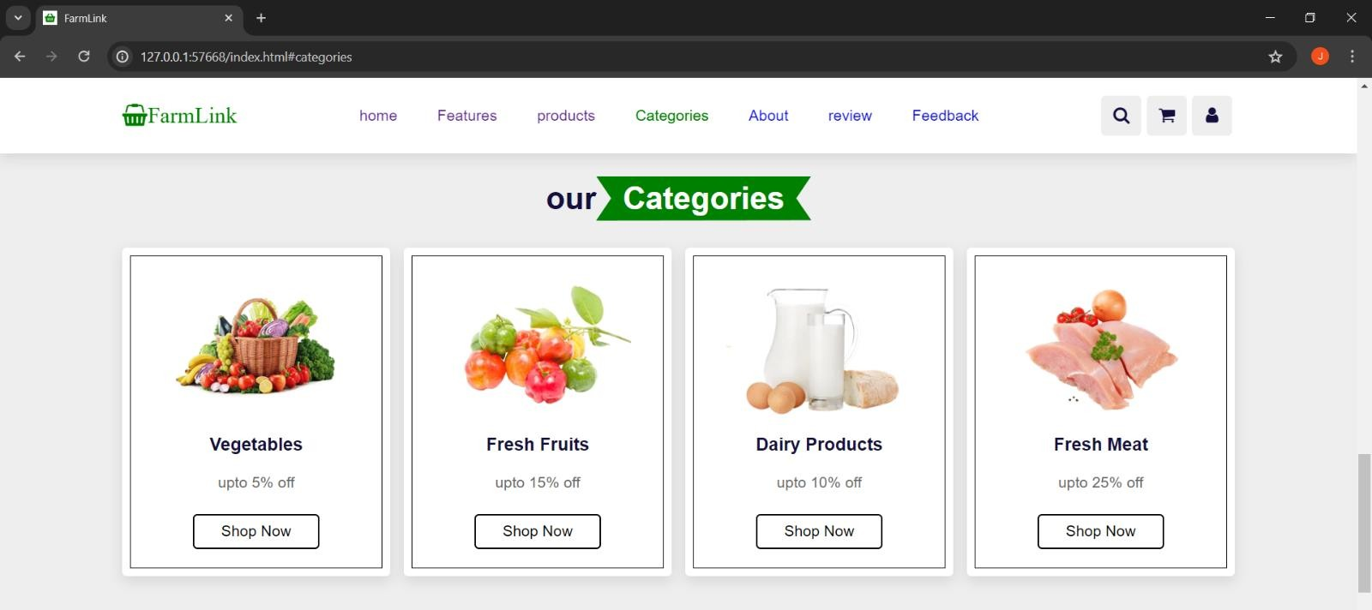

▪

**Vegetable**

**s Section:**

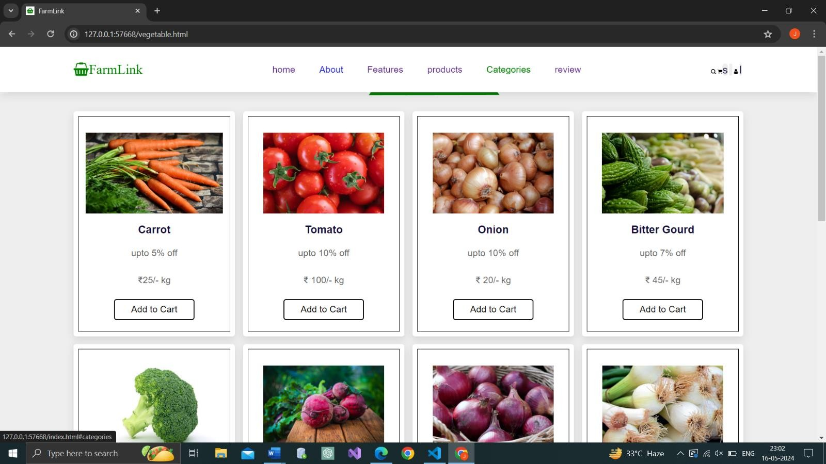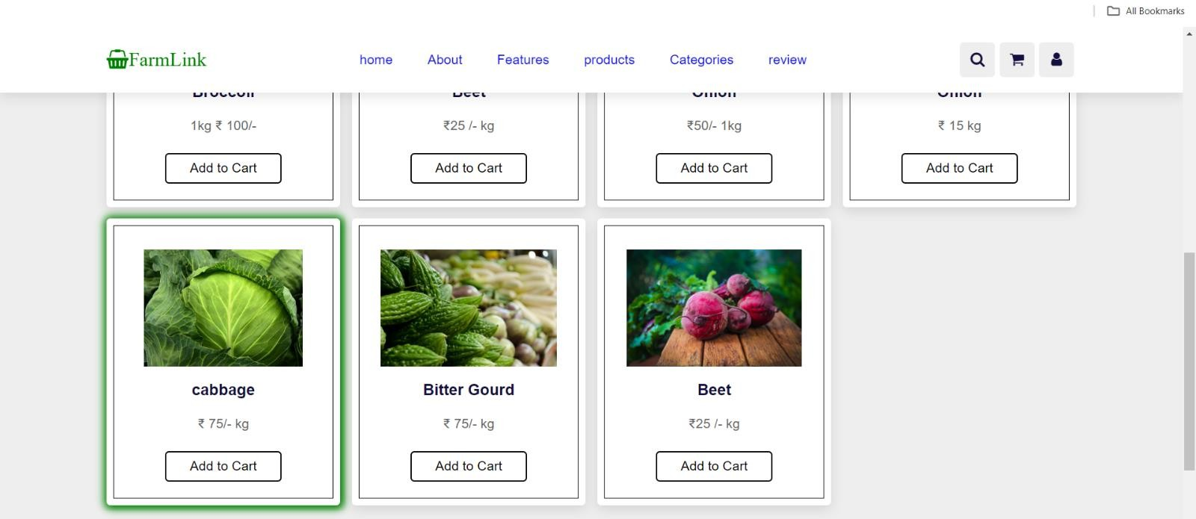

▪

**Fruits Section:**

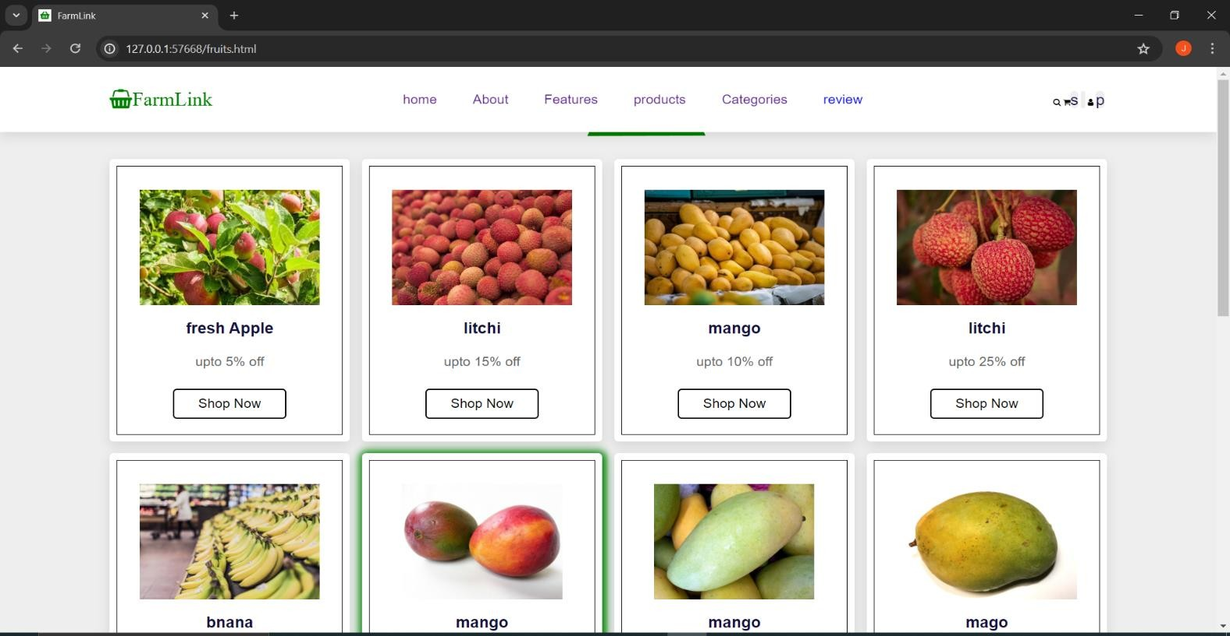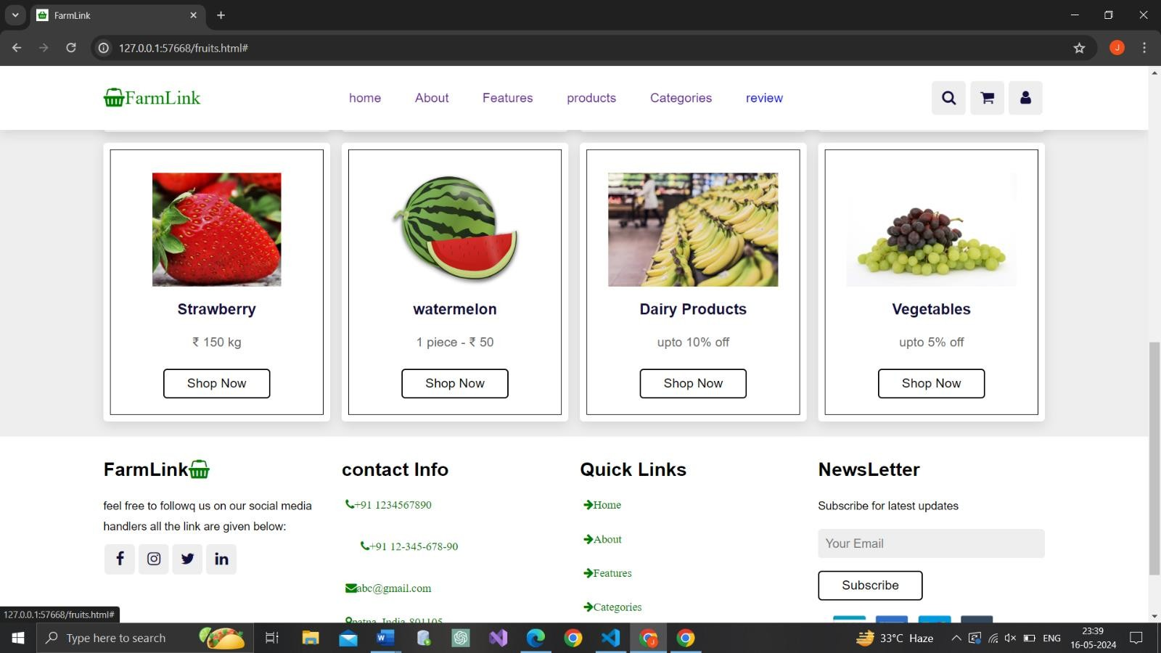

•

**Review section:**

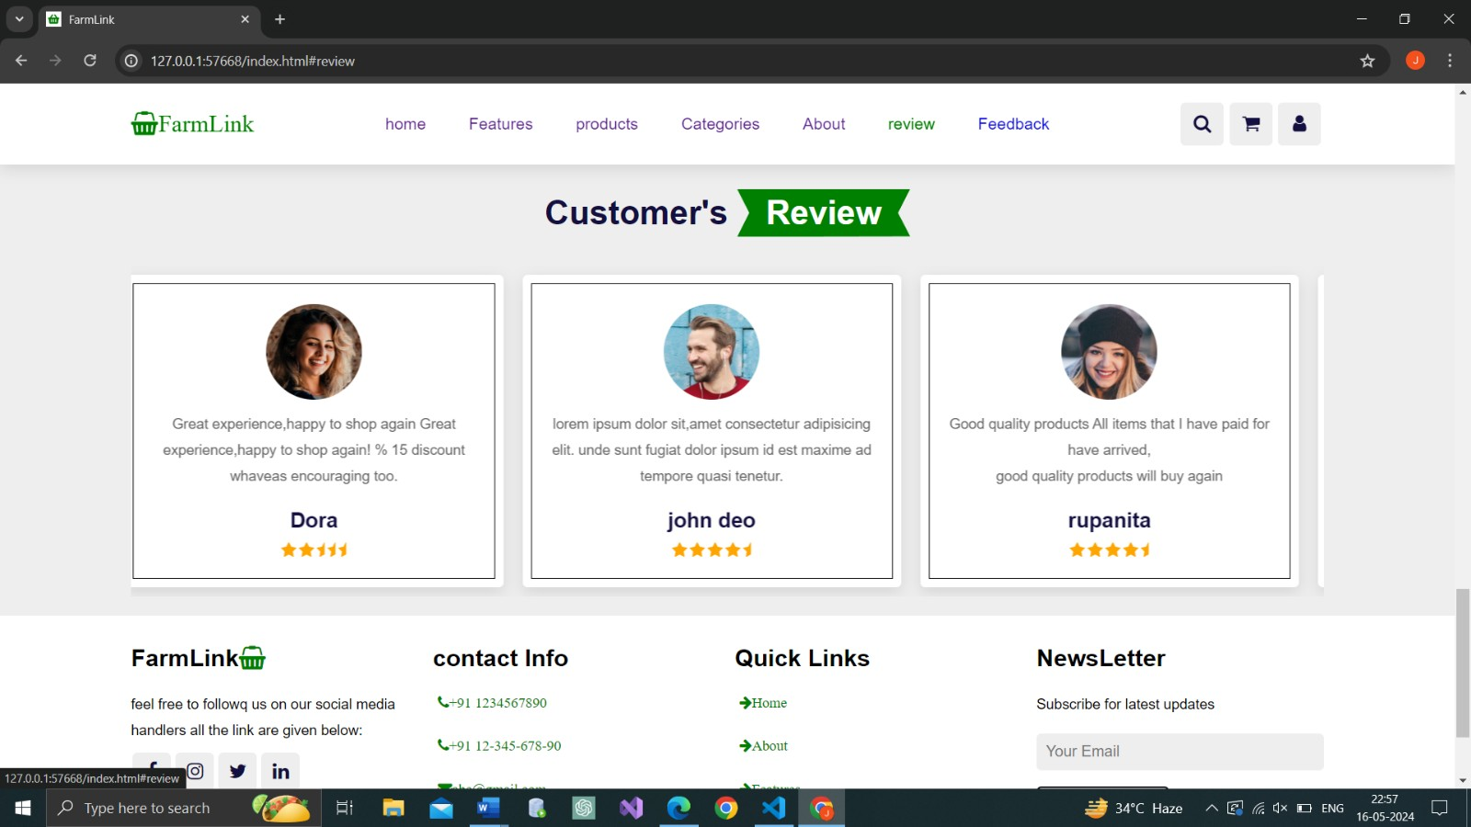

•

**Feedback Section:**

•

**After clicking the submit button:**

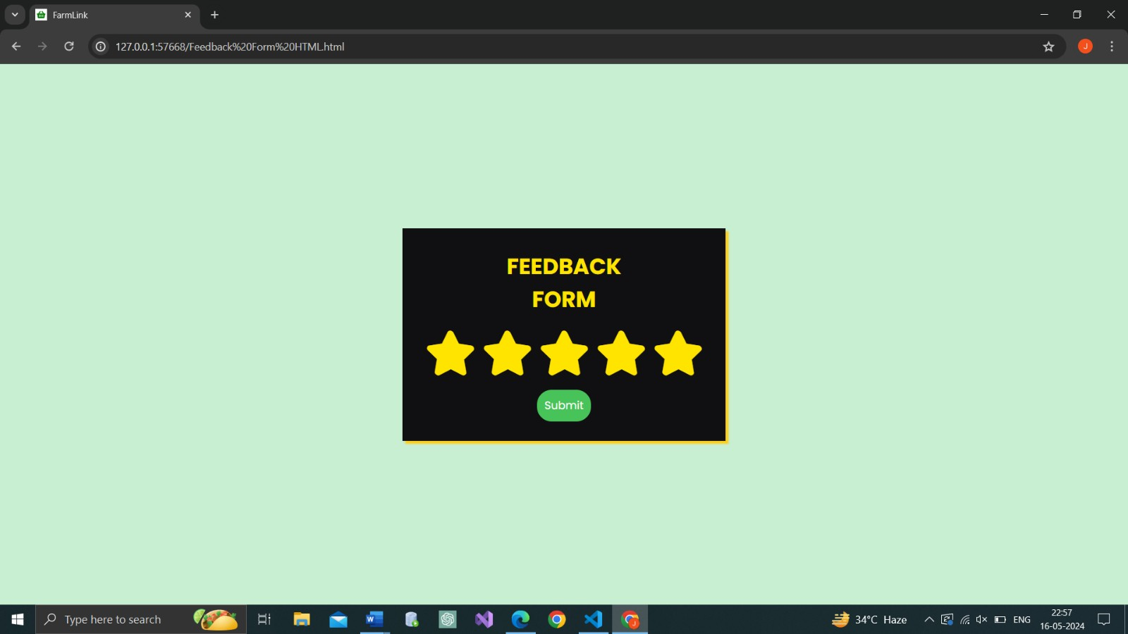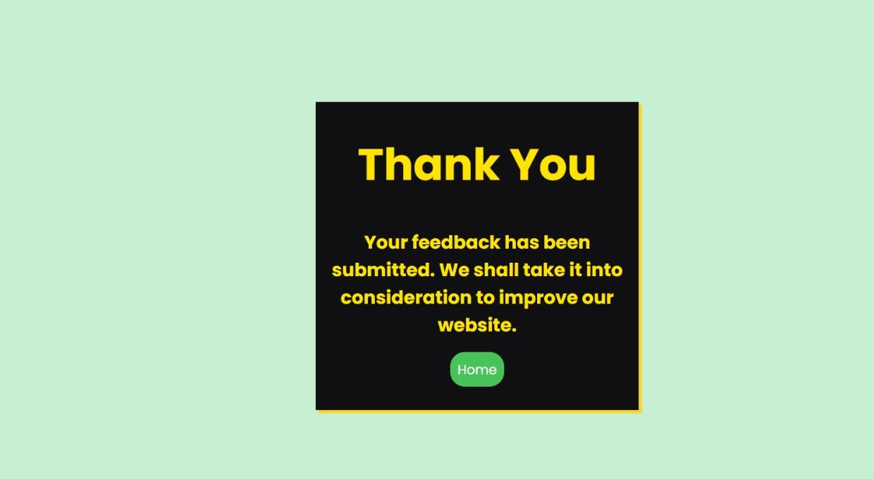

o

**Shopping cart section:**

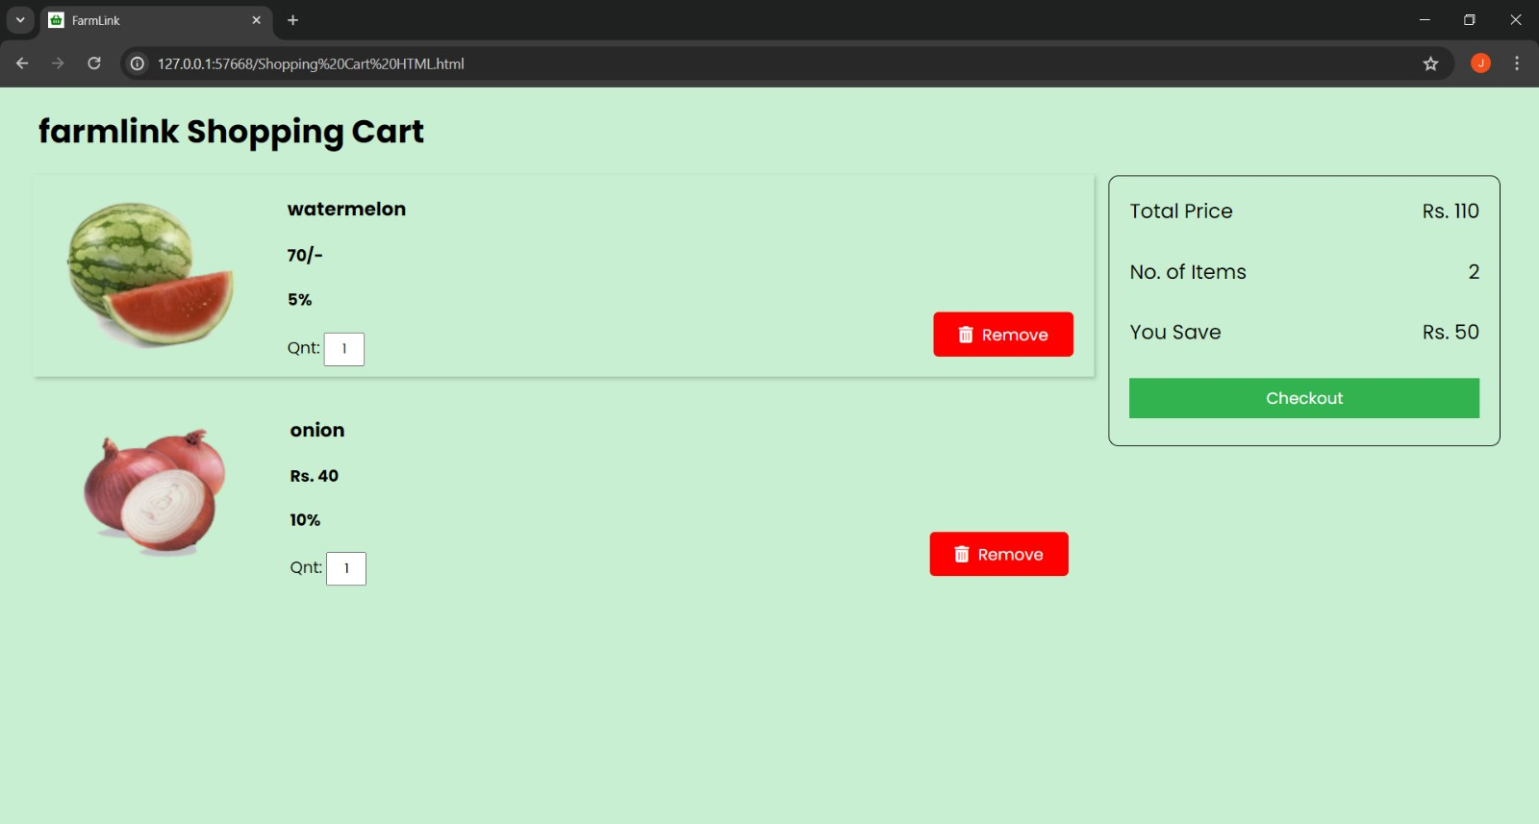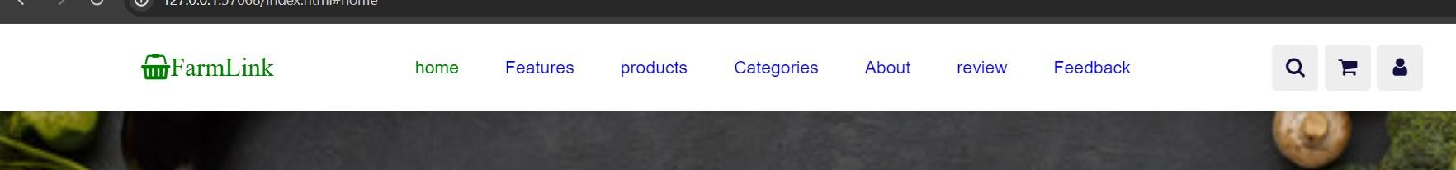

•

**After**

**Click**

**ing the**

**Checkout Button:**

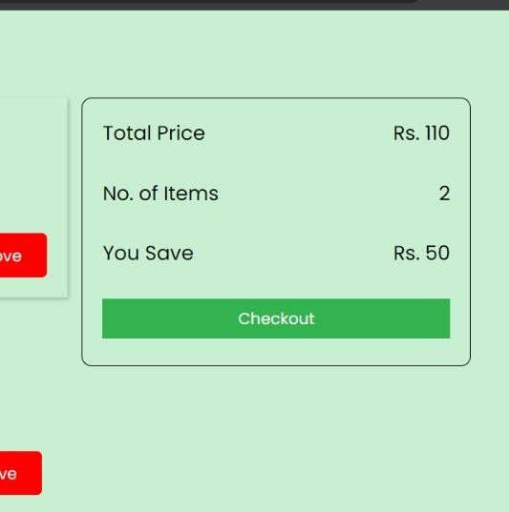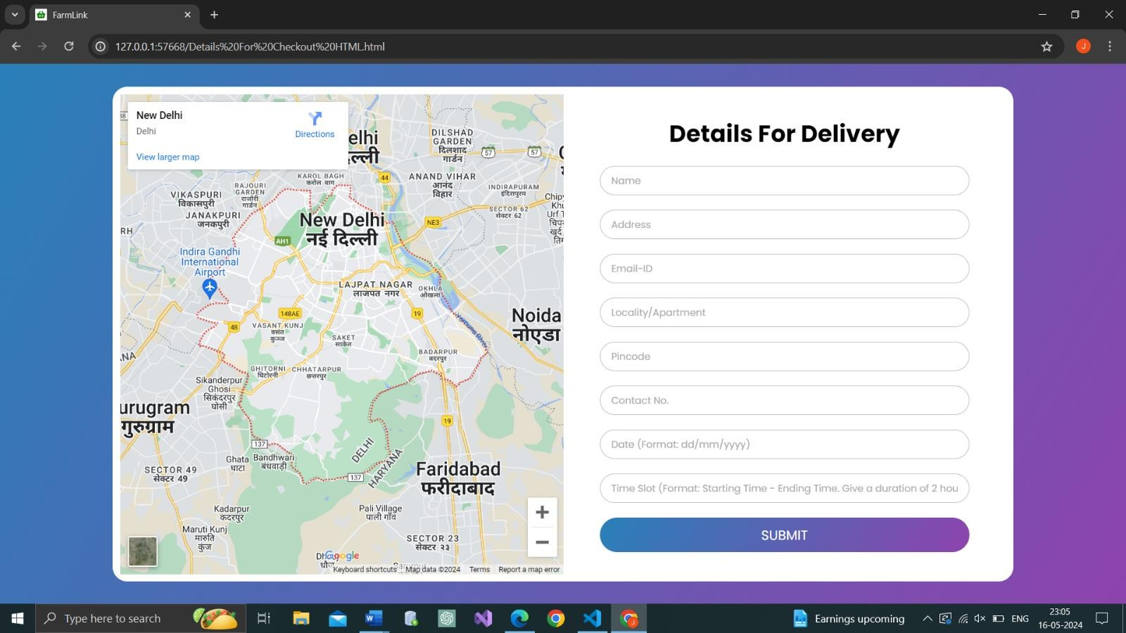

•

**Login form**

**:**

•

**After**

**Click**

**ing the**

**SIGNUP Button:**

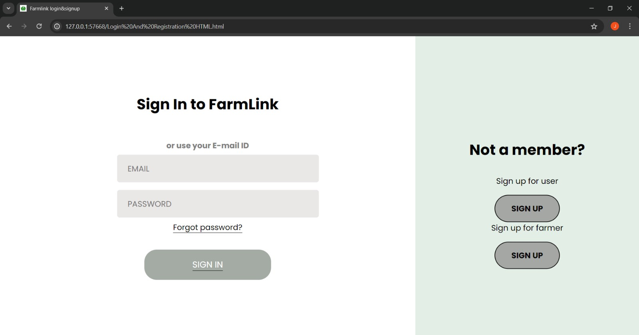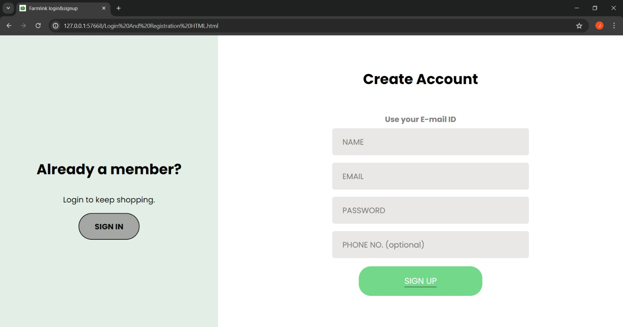

•

**Footer Section :**

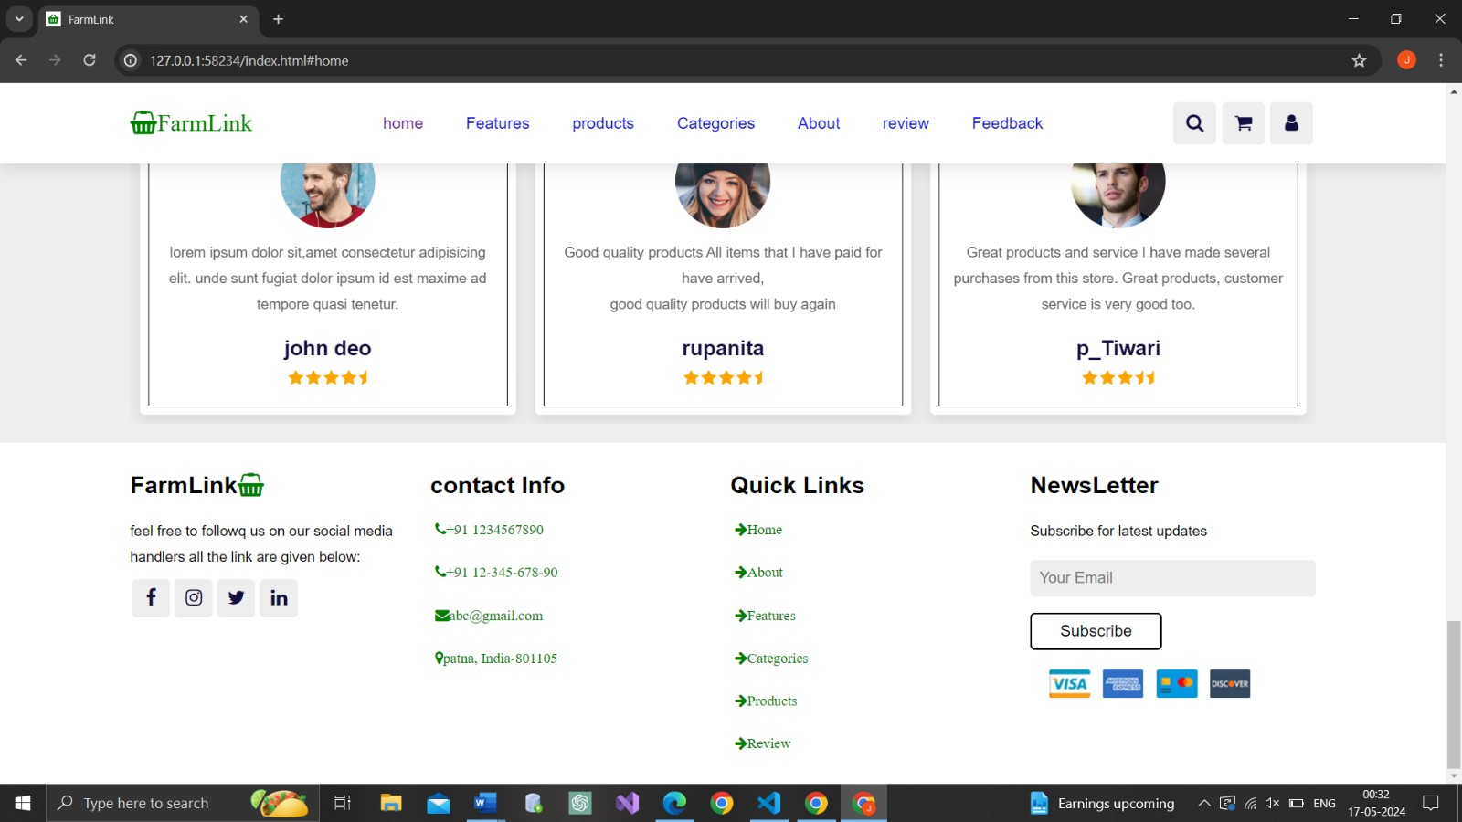

|  |
| --- |
| 7. secUrity issUes    There are different types of security measures implemented at various levels of the FlatFinder platform, described as follows:   1. **User Level:**   • Each user has a unique email and password for logging into the system, allowing them to view and manage only their own profile and saved flats after successful login. • After successful authentication, the system issues two encrypted tokens to the client (browser) to maintain session security and monitor user interactions.   1. **Admin Level:**   • Admins log in using their own secure email and password to access the Admin Dashboard of the FlatFinder system. • Admins have the rights to view all properties, remove inappropriate listings, and manage user accounts for security and quality control.   1. **Owner Level Security:**   • Authentication: Owners log in using their registered email and password. Only after successful authentication can they post and manage property listings. • Access Control: Owners can only add, update, or delete their own listings. The system prevents access to other owners' data, ensuring privacy.    **Backup:**  The FlatFinder database is hosted on a secure cloud server. In case of a technical failure or disaster, all critical data is safely backed up and can be restored from the latest cloud backup without data loss. |

|  |
| --- |
| 1. implementation & testing:      * 1. **Implementation:**   The implementation of the FlatFinder project involves transforming the conceptual design and functional requirements into a fully operational software application that can be used by renters, property owners, and administrators. This process includes coding the core features, integrating both frontend and backend components, setting up and managing the database, and ensuring the entire system works efficiently and reliably as intended.   * 1. **Coding Details :**       The term coding refers to writing lines of code for the system whose design has already been finalized. In the FlatFinder application, HTML, CSS, and JavaScript have been used for designing the user interface. For handling computation and operations involving the database, Python (Flask framework) has been used along with various supporting libraries for tasks such as user authentication, token generation and decoding, and secure session management. The following are the coding details for various pages, including the business logic and database connection implemented in the system. |

|  |
| --- |
|  |

|  |
| --- |
| <a href="#features">Features</a>  <a href="#Products">products</a>  <a href="#categories">Categories</a>  <a href="#about"> About </a>  <a href="#review">review</a>  <a href="Feedback Form HTML.html"> Feedback</a>  </nav>    <div class="icons">  <a href="#" id="search-btn" class="fa fa-search"></a>  <a href="Shopping Cart HTML.html" id="cart-btn" class="fa fa-shopping-cart"></a>  <a href="Login And Registration HTML.html" id="login-btn" class="fa fa-user"></a>  <a href="#" id="menu-btn" class="fa fa-bars"></a>  </div>  **<!--Search bar-->**  <form class="search-form">  <input type="search" id="search-box" placeholder="search here...">  <label for="search-box" class="fa fa-search"></label>  </form>  </header>  ▪ **<!--home section-->**    <section class="home" id="home" > |

|  |
| --- |
| <div class="content">  <h3>Fress And <span >Organic </span>Products for you</h3>  <p>hellow everyone</p>  <a href="#categories" class="btn">**Shop Now**</a>  </div>  </section>    **<!--our features section-->**  <section class="features" id="features">  <h1 class="heading">Our <span> Features </span></h1>  <div class="box-container">  <div class="box">  <img src="image/feature-img-1.png">  <h3>Fresh and Organic</h3>  <p>lorem,Ipsum Dolor sit amet consectetur Adipisicing Elit.  Deserunt, Earum!</p>  <a href="#Products" class="btn">Read More</a> </div>  <div class="box">  <img src="image/feature-img-2.png">  <h3>Free Delivery</h3>  <p>lorem,Ipsum Dolor sit amet consectetur Adipisicing Elit.  Deserunt, Earum!</p> |

|  |
| --- |
| <a href="#" class="btn">Read More</a>  </div>  <div class="box">  <img src="image/feature-img-3.png">  <h3>Easy payment</h3>  <p>lorem,Ipsum Dolor sit amet consectetur Adipisicing Elit.  Deserunt, Earum!</p>  <a href="#" class="btn">Read More</a>  </div>  </div>  </section>    **<!--our product section-->**  <section class="Products" id="Products">  <h1 class="heading">our <span>Products</span></h1>  <div class="swiper product-slider">  <div class="swiper-wrapper">  <div class="swiper-slide box">  <img src="image/product-1.png" >  <h1>Fresh orange</h1>  <div class="price">$30/- - 40/-</div>  <div class="stars"> |

|  |
| --- |
| <i class="fa fa-star"></i>  <i class="fa fa-star"></i>  <i class="fa fa-star"></i>  <i class="fa fa-star-half"></i> <i class="fa fa-star-half"></i>  </div>  <a href="" class="btn">add to cart</a>  </div>    <div class="swiper-slide box">  <img src="image/product-2.png" >  <h1>Fresh Onion</h1>  <div class="price">$15.99/- - 35.99/-</div>  <div class="stars">  <i class="fa fa-star"></i>  <i class="fa fa-star"></i>  <i class="fa fa-star"></i>  <i class="fa fa-star"></i>  <i class="fa fa-star-half"></i>  </div>  <a href="" class="btn">add to cart</a>  </div> |

|  |
| --- |
| <div class="swiper-slide box">  <img src="image/product-3.png" >  <h1>Fresh chicken</h1>  <div class="price">$99.99/- - 200.99/-</div>  <div class="stars">  <i class="fa fa-star"></i>  <i class="fa fa-star"></i>  <i class="fa fa-star"></i>  <i class="fa fa-star"></i>  <i class="fa fa-star-half"></i>  </div>  <a href="" class="btn">add to cart</a>  </div>  <div class="swiper-slide box">  <img src="image/product-4.png" >  <h1>Fresh Cabbage</h1>  <div class="price">$12.99/- - 18.99/-</div>  <div class="stars">  <i class="fa fa-star"></i>  <i class="fa fa-star"></i>  <i class="fa fa-star"></i>  <i class="fa fa-star"></i>  <i class="fa fa-star-half"></i> |

|  |
| --- |
| </div>  <a href="" class="btn">add to cart</a>  </div>    <div class="swiper-slide box">  <img src="image/product-5.png" >  <h1>Fresh Potato</h1>  <div class="price">$20.99/- - 25.99/-</div>  <div class="stars">  <i class="fa fa-star"></i>  <i class="fa fa-star"></i>  <i class="fa fa-star"></i>  <i class="fa fa-star"></i>  <i class="fa fa-star-half"></i>  </div>  <a href="" class="btn">add to cart</a>  </div>    <div class="swiper-slide box">  <img src="image/tomato.jpg" >  <h1>Fresh tomato</h1>  <div class="price">150/- - 200/-</div>  <div class="stars"> |

|  |
| --- |
| <i class="fa fa-star"></i>  <i class="fa fa-star"></i>  <i class="fa fa-star"></i>  <i class="fa fa-star"></i>  <i class="fa fa-star-half"></i>  </div>  <a href="" class="btn">add to cart</a>  </div>  </div>  </div>  <div class="swiper product-slider">  <div class="swiper-wrapper">  <div class="swiper-slide box">  <img src="image/mango.jpg" >  <h1>Fresh mango</h1>  <div class="price">$ 99/- - 200.99/-</div>  <div class="stars">  <i class="fa fa-star"></i>  <i class="fa fa-star"></i>  <i class="fa fa-star"></i>  <i class="fa fa-star"></i>  <i class="fa fa-star-half"></i>  </div> |

|  |
| --- |
| <a href="" class="btn">add to cart</a>  </div>    <div class="swiper-slide box">  <img src="image/karela.jpg" >  <h1>Fresh Bitter Gourd</h1>  <div class="price">$60/- - 80.99/-</div>  <div class="stars">  <i class="fa fa-star"></i>  <i class="fa fa-star"></i>  <i class="fa fa-star"></i>  <i class="fa fa-star"></i>  <i class="fa fa-star-half"></i>  </div>  <a href="" class="btn">add to cart</a>  </div>    <div class="swiper-slide box">  <img src="image/watermelon.png" >  <h1>Fresh watermelon</h1>  <div class="price">$20.99/- - 99.99/-</div>  <div class="stars">  <i class="fa fa-star"></i> |

|  |
| --- |
| <i class="fa fa-star"></i>  <i class="fa fa-star"></i>  <i class="fa fa-star"></i>  <i class="fa fa-star-half"></i>  </div>  <a href="" class="btn">add to cart</a>  </div>  </div>  </div>  </section>    **<!--our categories section-->**  <section class="categories" id="categories">  <h1 class="heading">our<span>Categories</span></h1>    <div class="box-container">  <div class="box">  <img src="image/cat-1.png">  <h3>Vegetables</h3>  <p>upto 5% off</p>  <a href="**vegetable.html**" class="btn">Shop Now</a> </div>  <div class="box"> |

|  |
| --- |
| <img src="image/cat-2.png">  <h3>Fresh Fruits</h3>  <p>upto 15% off</p>  <a href="**fruits.html**" class="btn">Shop Now</a> </div>  <div class="box">  <img src="image/cat-3.png">  <h3>Dairy Products</h3>  <p>upto 10% off</p>  <a href="#" class="btn">Shop Now</a>  </div>  <div class="box">  <img src="image/cat-4.png">  <h3>Fresh Meat</h3>  <p>upto 25% off</p>  <a href="#" class="btn">Shop Now</a>  </div>  </div>  </section> |

|  |
| --- |
| **Vegetables.html:**  <!DOCTYPE html>  <html>    <head>  <title>FarmLink</title>  <link rel="icon" type="image/PNG " href="image/favicon.PNG">  <!-- code for font awsome -->  <link rel="stylesheet" href="https://cdnjs.cloudflare.com/ajax/libs/font-awesome/4.7.0/css/fontawesome.min.css">    <!-- code for linking css file -->  <link rel="stylesheet" type="text/css" href="styles.css">    <!--using swipper-->  <link rel="stylesheet" href="https://unpkg.com/swiper@7/swiper-bundle.min.css" />    <!--used create responsive -->  <meta name="viewport" content="width=device-width, initial-scale=1.0">    </head>    <body>  <header class="header">  <a href="#" class="logo"><i class="fa fa-shopping-basket" aria-hidden="true">FarmLink</i></a>    <nav class="navbar">  <a href="**index.html#home**"> home </a>  <a href="#about"> About </a>  <a href="index.html#features">Features</a> |

|  |
| --- |
| <a href="index.html#Products">products</a>  <a href="index.html#categories">Categories</a>    <a href="index.html#review">review</a>  </nav>  <div class="icons">  <a href="#" id="search-btn" class="fa fa-search"></a>  <a href="Shopping Cart HTML.html" id="cart-btn" class="fa fa-shopping-cart"></a>  <a href="Login And Registration HTML.html" id="login-btn" class="fa fa-user"></a>  <a href="#" id="menu-btn" class="fa fa-bars"></a> </div>    <!--Search bar-->  <form class="search-form">  <input type="search" id="search-box" placeholder="search here...">  <label for="search-box" class="fa fa-search"></label>    </form>    </header>    <section class="categories" id="categories">  <h1 class="heading">Fresh<span>Vegetables</span></h1>    <div class="box-container">  <div class="box">  <img src="image/gazar.jpg">  <h3>Carrot</h3>  <p>upto 5% off</p>  <p>₹25/- kg </p> |

|  |
| --- |
| <a href="#" class="btn">Add to Cart</a>    </div>  <div class="box">  <img src="image/tomato.jpg">  <h3>Tomato</h3>  <p>upto 10% off</p>  <p>₹ 100/- kg</p>  <a href="#" class="btn">Add to Cart</a>  </div>  <div class="box">  <img src="image/onion.jpg">  <h3>Onion</h3>  <p>upto 10% off</p>  <p>₹ 20/- kg</p>  <a href="#" class="btn">Add to Cart</a>  </div>  <div class="box">  <img src="image/karela.jpg">  <h3>Bitter Gourd</h3>  <p>upto 7% off</p>  <p>₹ 45/- kg</p>  <a href="#" class="btn">Add to Cart</a>  </div>  <div class="box">  <img src="image/appetite-1238251_1280.jpg">  <h3>Broccoli</h3>  <p> 1kg ₹ 100/-</p>  <a href="#" class="btn">Add to Cart</a> |

|  |
| --- |
| </div>  <div class="box">  <img src="image/beet.jpg">  <h3>Beet</h3>  <p> ₹25 /- kg </p>  <a href="#" class="btn">Add to Cart</a>  </div>  <div class="box">  <img src="image/onion2.jpg">  <h3>Onion</h3>  <p>₹50/- 1kg</p>  <a href="#" class="btn">Add to Cart</a>  </div>  <div class="box">  <img src="image/onion3.jpg">  <h3>Onion</h3>  <p>₹ 15 kg</p>  <a href="#" class="btn">Add to Cart</a>  </div>    <div class="box">  <img src="image/cabbage.jpg">  <h3>cabbage</h3>  <p>₹ 75/- kg</p>  <a href="#" class="btn">Add to Cart</a>  </div>  <div class="box">  <img src="image/karela.jpg">  <h3>Bitter Gourd</h3> |

|  |
| --- |
| <p>₹ 75/- kg</p>  <a href="#" class="btn">Add to Cart</a>  </div>  <div class="box">  <img src="image/beet.jpg">  <h3>Beet</h3>  <p> ₹25 /- kg </p>  <a href="#" class="btn">Add to Cart</a>    </div>  </div>  </section>    <!--footer section-->    <section class="footer">  <div class="box-container">  <div class="box">    <h3>FarmLink<i class="fa fa-shopping-basket"></i></h3>  <p>feel free to followq us on our social media handlers all the link are given below:</p>    <div class="share">  <a href="https://www.facebook.com/" class="fa fa-facebook"></a>  <a href="https://www.instagram.com/" class="fa fa-instagram"></a>  <a href="#" class="fa fa-twitter"></a>  <a href="#" class="fa fa-linkedin"></a>    </div>  </div> |

|  |
| --- |
| <div class="box">    <h3>contact Info</h3>  <a href="#" class="links"><i class="fa fa-phone">+91 1234567890</i></a>  <a href="#" class="links"><i class="fa fa-phone">+91 12-345-678-90</i></a>  <a href="#" class="links"><i class="fa fa-envelope">abc@gmail.com</i></a>  <a href="https://www.google.com/maps/dir//International+School+of+Management+Patna+-  +Best+College+for+BCA+%7C+BBA+%7C+BJMC+%7C+B.Com(P)%7C+PGDM+in+Patna,+Bihar,+Sar ari,+Hathiakandh+-+Ushri+-  +Khagaul+Rd,+Khagaul,+Patna,+Bihar+801105/data=!4m6!4m5!1m1!4e2!1m2!1m1!1s0x39ed55fd57ba50  7f:0xef9ba6d3f1d733e2?sa=X&ved=1t:57443&ictx=111"  class="links"><i class="fa fa-map-marker">patna, India-801105 </i></a>    </div>    <div class="box">  <h3>Quick Links</h3>  <a href="index.html#home" class="links"><i class="fa fa-arrow-right">Home</i></a>  <a href="index.html#about" class="links"><i class="fa fa-arrow-right">About</i></a>  <a href="index.html#features" class="links"><i class="fa fa-arrow-right">Features</i></a>  <a href="index.html#categories" class="links"><i class="fa fa-arrow-right">Categories</i></a>  <a href="index.html#Products" class="links"><i class="fa fa-arrow-right">Products</i></a>  <a href="index.html#review" class="links"><i class="fa fa-arrow-right">Review</i></a>  </div>  <div class="box">    <h3>NewsLetter</h3>  <p>Subscribe for latest updates</p>  <input type="email" placeholder="Your Email" class="email">  <input type="submit" value="Subscribe" class="btn" >  <img src="image/payment.png" class="payment-img"> |

|  |
| --- |
| </div>  </div>    </section>  <script src="https://cdn.jsdelivr.net/npm/swiper@11/swiper-bundle.min.js"></script>  <script src="script.js"></script>  </body>    </html>    ▪ **Fruits.html :**    <!DOCTYPE html>  <html>  <head>  <title>FarmLink</title>  <link rel="icon" type="image/PNG " href="image/favicon.PNG">  <!-- code for font awsome -->  <link rel="stylesheet" href="https://cdnjs.cloudflare.com/ajax/libs/font-awesome/4.7.0/css/fontawesome.min.css">    <!-- code for linking css file -->  <link rel="stylesheet" type="text/css" href="styles.css">    <!--using swipper-->  <link rel="stylesheet" href="https://unpkg.com/swiper@7/swiper-bundle.min.css" /> <!--used create responsive -->  <meta name="viewport" content="width=device-width, initial-scale=1.0">    </head> |

|  |
| --- |
| <body>  <header class="header">  <a href="#" class="logo"><i class="fa fa-shopping-basket" aria-hidden="true">FarmLink</i></a>    <nav class="navbar">  <a href="index.html#home"> home </a>  <a href="index.html#about"> About </a>  <a href="index.html#features">Features</a>  <a href="index.html#Products">products</a>  <a href="index.html#categories">Categories</a>    <a href="#review">review</a>  </nav>    <div class="icons">  <a href="#" id="search-btn" class="fa fa-search"></a>  <a href="Shopping Cart HTML.html" id="cart-btn" class="fa fa-shopping-cart"></a>  <a href="Login And Registration HTML.html" id="login-btn" class="fa fa-user"></a>  <a href="#" id="menu-btn" class="fa fa-bars"></a>  </div>  <!--Search bar-->  <form class="search-form">  <input type="search" id="search-box" placeholder="search here...">  <label for="search-box" class="fa fa-search"></label> </form>  </header>  </section>  <section class="categories" id="categories">  <h1 class="heading">Fresh<span>fruits</span></h1> |

|  |
| --- |
| <div class="box-container">  <div class="box">  <img src="image/apple.jpg">  <h3>fresh Apple</h3>  <p>upto 5% off</p>  <a href="#" class="btn">Shop Now</a>  </div>  <div class="box">  <img src="image/lichi.jpg">  <h3>litchi</h3>  <p>upto 15% off</p>  <a href="#" class="btn">Shop Now</a>  </div>  <div class="box">  <img src="image/mango.jpg">  <h3>mango</h3>  <p>upto 10% off</p>  <a href="#" class="btn">Shop Now</a>  </div>  <div class="box">  <img src="image/lychee.jpg">  <h3>litchi</h3>  <p>upto 25% off</p>  <a href="#" class="btn">Shop Now</a>  </div>  <div class="box">  <img src="image/bnana.jpg">  <h3>bnana</h3>  <p>7% off </p>  <p>1kg ₹60</p> |

|  |
| --- |
| <a href="#" class="btn">Shop Now</a>  </div>  <div class="box">  <img src="image/mango2.jpg">  <h3>mango</h3>  <p>5% off </p>  <p>2 Mango - ₹25 </p>  <a href="#" class="btn">Shop Now</a>  </div>  <div class="box">  <img src="image/mango3.jpg">  <h3>mango</h3>  <p>5% off</p>  <p>₹120 - 1kg</p>  <a href="#" class="btn">Shop Now</a>  </div>  <div class="box">  <img src="image/mangoo.jpg">  <h3>mago</h3>  <p>₹ 15 </p>  <a href="#" class="btn">Shop Now</a> </div>    <div class="box">  <img src="image/Strawberry.jpg">  <h3>Strawberry</h3>  <p>₹ 150 kg</p>  <a href="#" class="btn">Shop Now</a>  </div>  <div class="box"> |

|  |
| --- |
| <img src="image/watermelon.png">  <h3>watermelon</h3>  <p> 1 piece - ₹ 50</p>  <a href="#" class="btn">Shop Now</a>  </div>  <div class="box">  <img src="image/bnana.jpg">  <h3>Dairy Products</h3>  <p>upto 10% off</p>  <a href="#" class="btn">Shop Now</a>  </div>  <div class="box">  <img src="image/angur.jpg">  <h3>Vegetables</h3>  <p>upto 5% off</p>  <a href="#" class="btn">Shop Now</a>  </div>  </div>  </section>    <!--footer section-->  <section class="footer">  <div class="box-container">  <div class="box">    <h3>FarmLink<i class="fa fa-shopping-basket"></i></h3>  <p>feel free to followq us on our social media handlers all the link are given below:</p>    <div class="share">  <a href="https://www.facebook.com/" class="fa fa-facebook"></a> |

|  |
| --- |
| <a href="https://www.instagram.com/" class="fa fa-instagram"></a>  <a href="#" class="fa fa-twitter"></a>  <a href="#" class="fa fa-linkedin"></a>  </div>  </div>    <div class="box">  <h3>contact Info</h3>  <a href="#" class="links"><i class="fa fa-phone">+91 1234567890</i></a>  <a href="#" class="links"><i class="fa fa-phone">+91 12-345-678-90</i></a>  <a href="#" class="links"><i class="fa fa-envelope">abc@gmail.com</i></a>  <a href="https://www.google.com/maps/dir//International+School+of+Management+Patna++Best+College+for+BCA+%7C+BBA+%7C+BJMC+%7C+B.Com(P)%7C+PGDM+in+Patna,+Bihar,+Sar ari,+Hathiakandh+-+Ushri+-  +Khagaul+Rd,+Khagaul,+Patna,+Bihar+801105/data=!4m6!4m5!1m1!4e2!1m2!1m1!1s0x39ed55fd57ba50  7f:0xef9ba6d3f1d733e2?sa=X&ved=1t:57443&ictx=111"  class="links"><i class="fa fa-map-marker">patna, India-801105 </i></a>    </div>  <div class="box">    <h3>Quick Links</h3>  <a href="index.html#home" class="links"><i class="fa fa-arrow-right">Home</i></a>  <a href="index.html#about" class="links"><i class="fa fa-arrow-right">About</i></a>  <a href="index.html#features" class="links"><i class="fa fa-arrow-right">Features</i></a>  <a href="index.html#categories" class="links"><i class="fa fa-arrow-right">Categories</i></a>  <a href="index.html#Products" class="links"><i class="fa fa-arrow-right">Products</i></a>  <a href="index.html#review" class="links"><i class="fa fa-arrow-right">Review</i></a>  </div>  <div class="box">    <h3>NewsLetter</h3> |

|  |
| --- |
| <p>Subscribe for latest updates</p>  <input type="email" placeholder="Your Email" class="email">  <input type="submit" value="Subscribe" class="btn" >  <img src="image/payment.png" class="payment-img">  </div>  </div>  </section>  <script src="https://cdn.jsdelivr.net/npm/swiper@11/swiper-bundle.min.js"></script>  <script src="script.js"></script>  </body>  </html>  **<!-- Review Section-->**    <section class="review" id="review">  <h1 class="heading">Customer's <span>Review</span></h1>    <div class="swiper review-slider">  <div class="swiper-wrapper">  <div class="swiper-slide box">  <img src="image/pic-1.png">  <p>lorem ipsum dolor sit,amet consectetur adipisicing elit. unde sunt fugiat dolor ipsum id est maxime ad tempore quasi tenetur.</p>  <h3>john deo</h3>    <div class="stars">  <i class="fa fa-star"></i> |

|  |
| --- |
| <i class="fa fa-star"></i>  <i class="fa fa-star"></i>  <i class="fa fa-star"></i>  <i class="fa fa-star-half"></i>  </div>  </div>    <div class="swiper-slide box">  <img src="image/pic-2.png">  <p>Good quality products  All items that I have paid for have arrived,<br> good quality products will buy again</p> <h3>rupanita</h3>    <div class="stars">  <i class="fa fa-star"></i>  <i class="fa fa-star"></i>  <i class="fa fa-star"></i>  <i class="fa fa-star"></i>  <i class="fa fa-star-half"></i>  </div>  </div>  <div class="swiper-slide box">  <img src="image/pic-3.png"> |

|  |
| --- |
| <p>Great products and service  I have made several purchases from this store.  Great products, customer service is very good too.</p> <h3>p_Tiwari</h3>    <div class="stars">  <i class="fa fa-star"></i>  <i class="fa fa-star"></i>  <i class="fa fa-star"></i>  <i class="fa fa-star-half"></i> <i class="fa fa-star-half"></i>  </div>  </div>    <div class="swiper-slide box">  <img src="image/pic-4.png">  <p>Great experience,happy to shop again  Great experience,happy to shop again! % 15 discount whaveas encouraging too.</p> <h3>Dora</h3>    <div class="stars">  <i class="fa fa-star"></i>  <i class="fa fa-star"></i> |

|  |
| --- |
| <i class="fa fa-star-half"></i>  <i class="fa fa-star-half"></i> <i class="fa fa-star-half"></i>  </div>    </div>  </div>  </div>  </section>  **<!--footer section-->**  <section class="footer">  <div class="box-container">  <div class="box">  <h3>FarmLink<i class="fa fa-shopping-basket"></i></h3>  <p>feel free to followq us on our social media handlers all the link are given below:</p> <div class="share">  <a href="https://www.facebook.com/" class="fa fa-facebook"></a>  <a href="https://www.instagram.com/" class="fa fa-instagram"></a>  <a href="#" class="fa fa-twitter"></a>  <a href="#" class="fa fa-linkedin"></a>  </div>  </div>  <div class="box"> |

|  |
| --- |
| <h3>contact Info</h3>  <a href="#" class="links"><i class="fa fa-phone">+91 1234567890</i></a>  <a href="#" class="links"><i class="fa fa-phone">+91 12-345-678-90</i></a>  <a href="#" class="links"><i class="fa fa-envelope">abc@gmail.com</i></a>  <a href="https://www.google.com/maps/dir//International+School+of+Management+Patna+-  +Best+College+for+BCA+%7C+BBA+%7C+BJMC+%7C+B.Com(P)%7C+PGDM+in+Patna,+  Bihar,+Sarari,+Hathiakandh+-+Ushri+-  +Khagaul+Rd,+Khagaul,+Patna,+Bihar+801105/data=!4m6!4m5!1m1!4e2!1m2!1m1!1s0x39ed5  5fd57ba507f:0xef9ba6d3f1d733e2?sa=X&ved=1t:57443&ictx=111"  class="links"><i class="fa fa-map-marker">patna, India-801105 </i></a> </div>  <div class="box">  <h3>Quick Links</h3>  <a href="#home" class="links"><i class="fa fa-arrow-right">Home</i></a>  <a href="#about" class="links"><i class="fa fa-arrow-right">About</i></a>  <a href="#features" class="links"><i class="fa fa-arrow-right">Features</i></a>  <a href="#categories" class="links"><i class="fa fa-arrow-right">Categories</i></a>  <a href="#Products" class="links"><i class="fa fa-arrow-right">Products</i></a>  <a href="#review" class="links"><i class="fa fa-arrow-right">Review</i></a>  </div>  <div class="box">  <h3>NewsLetter</h3>  <p>Subscribe for latest updates</p>  <input type="email" placeholder="Your Email" class="email"> |

|  |
| --- |
| <input type="submit" value="Subscribe" class="btn" >  <img src="image/payment.png" class="payment-img">  </div>  </div>  </section>  <script src="https://cdn.jsdelivr.net/npm/swiper@11/swiper-bundle.min.js"></script>  <script src="script.js"></script>  </body>  </html>    **//search bar**  let searchForm=document.querySelector('.search-form'); document.querySelector('#search-btn').onclick = () =>  {  searchForm.classList.toggle('active');    shoppingCart.classList.remove('active'); loginForm.classList.remove('active'); navbar.classList.remove('active');    }    **//shopping cart** |

|  |
| --- |
| let shoppingCart=document.querySelector('.shopping-cart'); document.querySelector('#cart-btn').onclick = () =>  { shoppingCart.classList.toggle('active');    searchForm.classList.remove('active'); loginForm.classList.remove('active'); navbar.classList.remove('active');  }      //login form    let loginForm=document.querySelector('.login-form'); document.querySelector('#login-btn').onclick = () =>  { loginForm.classList.toggle('active');    searchForm.classList.remove('active'); shoppingCart.classList.remove('active'); navbar.classList.remove('active');  } |

|  |
| --- |
| //navbar in mobile screen    let navbar=document.querySelector('.navbar'); document.querySelector('#menu-btn').onclick = () =>  { navbar.classList.toggle('active'); searchForm.classList.remove('active'); shoppingCart.classList.remove('active'); loginForm.classList.remove('active');    }    window.onscroll = () =>  {  searchForm.classList.remove('active'); shoppingCart.classList.remove('active'); loginForm.classList.remove('active'); navbar.classList.remove('active');    } |

|  |
| --- |
| **//implimenting swiper**    var swiper = new Swiper(".product-slider", { loop:true, spaceBetween: 20,    autoplay:{ delay: 2500, disableOnInteraction: false,    },    breakpoints: {  0: { slidesPerView: 1,    },  768: { slidesPerView: 2,    },  1020: { slidesPerView: 3, |

|  |
| --- |
| },  },  });    **/*review section*/**  var swiper = new Swiper(".review-slider", { loop:true, spaceBetween: 20,    autoplay:{ delay: 2500, disableOnInteraction: false,    },    breakpoints: {  0: { slidesPerView: 1,    },  768: { slidesPerView: 2, |

|  |
| --- |
| },  1020: { slidesPerView: 3,    },  },  });      ▪ **Shopping cart.html :**    <!DOCTYPE html>  <html>  <head>  <title>FarmLink</title>  <link rel="icon" type="image/PNG " href="image/favicon.PNG" />  <link rel="stylesheet" type="text/css" href="Shopping Cart CSS.css" />  <script src="https://kit.fontawesome.com/9088cc6401.js" crossorigin="anonymous"></script>  </head>  <body>  <div class="container">  <h1>farmlink Shopping Cart</h1>  <div class="cart">  <div class="products">  <div class="product">  <img src="image/cart-img-1.png" />  <div class="product-info"> |

|  |
| --- |
| <h3 class="product-name">watermelon</h3>  <h4 class="product-price">70/-</h4>  <h4 class="product-offer">5%</h4>  <p class="product-quantity">  Qnt:  <input value="1" name="" />  </p>  <p class="product-remove">  <i class="fas fa-trash-alt"></i>  <span class="remove">Remove</span>  </p>  </div>  </div>  <div class="product">  <img src="image/cart-img-2.png" />  <div class="product-info">  <h3 class="product-name">onion</h3>  <h4 class="product-price">Rs. 40</h4>  <h4 class="product-offer">10%</h4>  <p class="product-quantity">  Qnt:  <input value="1" name="" />  </p>  <p class="product-remove">  <i class="fas fa-trash-alt"></i>  <span class="remove"> Remove </span>  </p>  </div>  </div>  </div>  <div class="cart-total">  <p><span>Total Price</span><span>Rs. 110</span></p>  <p><span>No. of Items</span><span>2</span></p> |

|  |
| --- |
| <p><span>You Save</span><span>Rs. 50</span></p>  <a href="Details For Checkout HTML.html">Checkout</a>  </div>  </div>  </div>  <script>  // JavaScript for removing products from the cart  const removeButtons = document.querySelectorAll(".product-remove"); removeButtons.forEach(button => { button.addEventListener("click", () => { button.closest(".product").remove(); updateCartTotal();  });  });  // JavaScript for updating total price function updateCartTotal() {  const products = document.querySelectorAll(".product"); let totalPrice = 0;  products.forEach(product => {  const priceElement = product.querySelector(".product-price");  const quantityElement = product.querySelector(".product-quantity input"); const price = parseFloat(priceElement.textContent.split("Rs. ")[1]); const quantity = parseInt(quantityElement.value); totalPrice += price * quantity;  });  document.querySelector(".cart-total span:nth-of-type(1)").textContent = "Rs. " + totalPrice;  }  </script>  </body>  </html> |

|  |
| --- |
| ▪ **Details checkout for html.html:**  <!DOCTYPE html>  <html>  <head>  <meta http-equiv="contact-type" content="text/html; charset-utf-8"/>  <meta name="viewport" content="width-device-width,initial-scale=1,mininmumscale=1,maximum-scale=1,user-scalable=no">  <title>FarmLink</title>  <link rel="icon" type="image/PNG " href="image/favicon.PNG">  <link href="Details For Checkout CSS.css" rel="stylesheet" type="text/css" />  <script src="Details For Checkout JS.js"></script>  </head>  <body>  <div class="contact-in">  <div class="contact-map">  <iframe  src="https://www.google.com/maps/embed?pb=!1m18!1m12!1m3!1d224345.8392319286 6!2d77.06889754725779!3d28.52758200617606!2m3!1f0!2f0!3f0!3m2!1i1024!2i768!4f1  3.1!3m3!1m2!1s0x390cfd5b347eb62d%3A0x52c2b7494e204dce!2sNew%20Delhi%2C% 20Delhi!5e0!3m2!1sen!2sin!4v1642929688022!5m2!1sen!2sin" width="100%" height="auto" style="border:0;" allowfullscreen="" loading="lazy"> </iframe>  </div>  <div class="contact-form">  <h1 align = 'center'> Details For Delivery </h1>  <div id="error_message"></div>  <form class = 'address_form' onsubmit="return validate_form();"> |

|  |
| --- |
| <input type="text" placeholder="Name" class="contact-form-txt" id = 'name' required/>  <input type="text" placeholder="Address" class="contact-form-txt" id = 'address' required/>  <input type="text" placeholder="Email-ID" class="contact-form-txt" id = 'email' required/>  <input type="text" placeholder="Locality/Apartment" class="contact-formtxt" required/>  <input type="text" placeholder="Pincode" class="contact-form-txt" id = 'pincode' required/>  <input type="text" placeholder="Contact No." class="contact-form-txt" id = 'phone' required/>  <input type="text" placeholder="Date (Format: dd/mm/yyyy)" class="contact-form-txt" id = 'date' required/>    <input type="text" placeholder="Time Slot (Format: Starting Time - Ending Time. Give a duration of 2 hours.)" class="contact-form-txt" id = 'time' required/>  <button type="submit" class="contact-form-btn" id = 'submit'>  <a href = 'index.html#home' style = "cursor: pointer; text-decoration: none; color: white;">Submit</a>  </button>  </form>  </div>  </div>  </body>  </html> |

|  |
| --- |
| **Details for checkout js.js**  function validate_form(){ var name=document.getElementById("name").value; var phone=document.getElementById("phone").value; var email=document.getElementById("email").value; var pincode=document.getElementById("pincode").value; var error_message=document.getElementById("error_message");    error_message.style.padding="10px";    var text; if(name.length<3){ text="Please Enter a valid Name"; error_message.innerHTML = text;  return false;  }  if(isNaN(phone) || phone.length !=10){ text="Please Enter a valid Phone Number"; error_message.innerHTML=text;  return false;  }  if(isNaN(pincode) || pincode.length !=10){ text="Please enter a valid Pincode"; error_message.innerHTML=text; |

|  |
| --- |
| return false;  }  if(email.indexof("@") == -1 || email.length < 6){ text="Please enter a valid E-mail ID."; error_message.innerHTML=text;  return false;  }  }    **Feedback form html.html:**    <!DOCTYPE html>  <html>    <head>  <title>FarmLink</title>  <link rel="icon" type="image/PNG " href="image/favicon.PNG">  <link rel="stylesheet" type="text/css" href="Feedback Form CSS.css">  <link rel="stylesheet" href="">  <script src="https://kit.fontawesome.com/9088cc6401.js" crossorigin="anonymous"></script>    <link rel="shortcut icon" type="image/jpg" href="C:\Users\hp\Desktop\College\First Semester\Introduction To Web Technologies\Notepad ++ Files\Project\favicon.ico"/> </head> |

|  |
| --- |
| <body>  <div class="rating-css">  <div style = "font-family: 'Poppins', sans-serif;">  Feedback <br> Form  </div>      <div class="star-icon">  <input type="radio" name="rating1" id="rating1">  <label for="rating1" class="fa fa-star"></label>  <input type="radio" name="rating1" id="rating2">  <label for="rating2" class="fa fa-star"></label>  <input type="radio" name="rating1" id="rating3">  <label for="rating3" class="fa fa-star"></label>  <input type="radio" name="rating1" id="rating4">  <label for="rating4" class="fa fa-star"></label>  <input type="radio" name="rating1" id="rating5">  <label for="rating5" class="fa fa-star"></label>  <button type="submit" class="btn"><a href="Feedback Form Confirm HTML and CSS.html"style = 'color: white; text-decoration: none;'>Submit</a></button>  </div>  </div>  </body>  </html> |

|  |
| --- |
| **Feedback Form Confirm HTML and CSS.html**    <!DOCTYPE html>  <html>  <head>  <title>FarmLink</title>  <link rel="icon" type="image/PNG " href="image/favicon.PNG">  <style>    @import  url('https://fonts.googleapis.com/css2?family=Poppins:wght@200;300;400;500;600;700&display=s wap');  *{  margin:0; padding:0;  font-family: 'Poppins', sans-serif;  }  body{  display:flex; min-height:100vh; align-items:center; justify-content:center; background: #c8efd1; |
| .box{  height:380px; width:400px; background:#101012; padding:20px;  box-shadow: 4px 4px 2px #fdd01c;  }  .box div{ color:#ffe400; font-size:30px;  font-family:sans-serif; font-weight:800; text-align:center; padding:20px 0;  }  .btn{  border-radius:20px; color:#fff; margin-top:18px; padding:10px;  background-color:#47c35a; font-size:18px; |
| border:none; cursor:pointer;  }  </style>    <link rel="shortcut icon" type="image/jpg" href="C:\Users\hp\Desktop\College\First  Semester\Introduction To Web Technologies\Notepad ++ Files\Project\favicon.ico"/>  </head>  <body>  <div class="box">  <div>  <h1>Thank You</h1><br>  <h5>Your feedback has been submitted. We shall take it into  consideration to improve our website.</h5>  <button type="button" class="btn"><a href="index.html#home"style =  'color: white; text-decoration: none;'>Home</a></button>  </div>  </div>  </body>  </html> |
| **8.3 Testing Approach:**    Testing is a crucial phase in the development lifecycle of the FlatFinder project, involving a systematic and well-structured process to assess the software application and ensure it fulfills the defined requirements and performs as expected. This phase is focused on identifying any bugs, flaws, or deviations from the intended behavior to enhance the overall quality and reliability of the FlatFinder platform.  The primary objectives of software testing include:  **Detecting Defects:** Identifying and resolving any errors or bugs present in the system.  **Validating Functionality:** Ensuring all features work correctly for renters, property owners, and administrators.  **Ensuring Reliability:** Verifying that the system operates consistently and accurately under various scenarios.  **Enhancing User Experience:** Improving the UI/UX to deliver a smooth and user-friendly experience for all users.  **Ensuring Performance and Scalability:** Making sure the platform handles expected user traffic and can scale efficiently.  **Maintaining Quality Standards:** Ensuring high standards of performance, security, and stability are maintained across the application. |

|  |
| --- |
| 1. conclUsion   **9.1 Conclusion: -**  The FlatFinder platform is designed to bridge the gap between property owners and renters, promoting easy access to affordable housing and simplifying the rental process. This project represents a significant step toward creating a more connected and efficient real estate experience, benefiting all stakeholders involved.  The FlatFinder system aims to revolutionize how property owners, renters, and administrators interact by offering a streamlined and user-friendly platform for posting, searching, and renting properties. The project is structured around three main modules: **Admin, Owner, and Renter**, each designed to cater to the unique needs of its users.  **Admin Module:**  The Admin module enables effective management of users and listings, ensuring that the platform remains secure and well-regulated. Admins can monitor all registered users, remove inappropriate listings, and ensure compliance with platform rules.  **Owner Module:**  The Owner module empowers property owners to list their properties with ease. Owners can add new listings, update rental details such as price, property type, and amenities, and delete listings when needed. This module is designed to help owners efficiently manage their rental offerings and reach potential tenants.  **Renter Module:**  The Renter module enhances the flat/room-hunting experience by offering features such as filtering properties by budget, accommodation type, and location, saving favorite listings, contacting owners, and scheduling flat visits. This module is focused on delivering a simple and effective way for renters to find suitable accommodations. |

|  |
| --- |
| **9.2 Limitation of Project: -**  • The system is a basic-level project designed to provide a foundational structure for future enhancements and expansion. • Additional functionalities and features are expected to be developed later based on user requirements and feedback. • Users must have access to the website through a LAN or an active internet connection to use the application effectively.    **9.3**  **Future Scope & Enhancement:-**  Future enhancements for the FlatFinder project aim to improve usability, accessibility, and overall system efficiency. Potential developments include expanding the platform to support additional property types such as commercial spaces, PG accommodations, and shared living options to cater to a wider audience.  Integration with dedicated **mobile applications** for both Android and iOS devices will further enhance user convenience, allowing property searches, booking visits, and owner-renter communication to be managed seamlessly from anywhere.  The system could also incorporate **real-time chat features**, allowing renters to communicate directly with property owners or agents. Additionally, an **AI-powered recommendation system** can be introduced to suggest properties based on user preferences, location history, and past interactions.  For improved service delivery, partnerships with **local logistics and relocation companies** may be explored, enabling users to book transport or moving services directly through the platform.  Advanced **payment gateway integration** could also be introduced for collecting deposits, booking fees, or monthly rent payments securely.  Furthermore, introducing **user review and rating systems** would help maintain transparency and build trust within the platform. As the user base grows, the system architecture may also need to be scaled to handle high traffic and ensure reliable performance under load. |

|  |
| --- |
| **9.4 Bibliography: -**    <https://www.bigbasket.com/> <https://www.w3schools.com/html/> <https://fontawesome.com/> <https://swiperjs.com/>          P a g e |